Organizer of the 50th Karlovy Vary IFF 2015: Film Servis Festival Karlovy Vary, a.s.

Organizers of the 50th Karlovy Vary IFF thanks to all partners which help to organize the festival.

50th Karlovy Vary IFF is supported by:
Ministry of Culture Czech Republic
General partner: CEZ Group
Main partners: RWE
Vodafone Czech Republic a.s.
City of Karlovy Vary
Partners: Karlovy Vary Region
UniCredit Bank Czech Republic and Slovakia, a.s.
UNIPETROL, a.s.
KKCG investment group
Lobkowicz Premium
construction group EUROVIA CS
Official insurer: Allianz Insurance
Official car: BMW
Official beverage: Karlovarská Korunní
Official electronics supplier: LG Electronics
Official drink: Finlandia Vodka
Official champagne: Moët & Chandon
Official coffee: Nespresso
Official make-up artist: Douglas
Official Fest Food: Bageterie Boulevard
Carrier: Air France
International shipping partner: DHL Express (Czech Republic), s.r.o.

Main media partners: Czech Television
Český rozhlas
PRÁVO
Novinky.cz
REFLEX
Media partners: JCDecaux Group
InStyle
magazine TV Star
Radio 1
tablet-only weekly DOTYK
Festival awards supplier: MOSER, a.s.
Hardware supplier: Fujitsu
Software solutions: Microsoft
Wine supplier: Víno Marcinčák

Partner of the festival Instagram: SWISSDENT
Main hotel partners: The Augustine Prague
SPA HOTEL THERMAL
Grandhotel Pupp
Official bike: Specialized
Partner of the No Barriers Project: RWE Energie
Non-profit partner: Alliance of Women with Breast Cancer

RICHARD GERE TO RECEIVE CRYSTAL GLOBE FOR OUTSTANDING CONTRIBUTION TO WORLD CINEMA
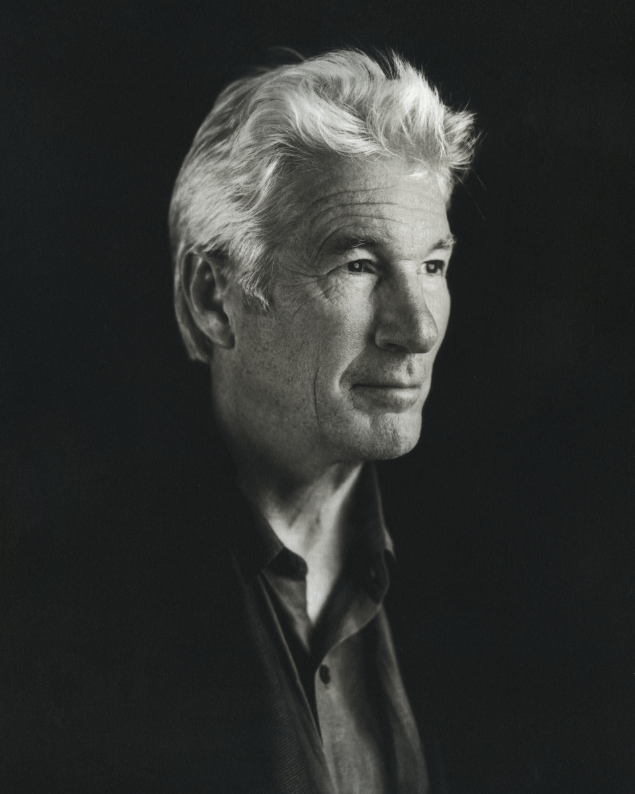
The 50th Karlovy Vary IFF will honour distinguished American actor Richard Gere with its highest award – the Crystal Globe for Outstanding Contribution to World Cinema.
Richard Gere is one of today’s most highly regarded actors. His rich filmography spans diverse genres, includes creative collaborations with major directors and shows the artistic temerity to work on roles that defy standard typological classification.
As a talented young man from Philadelphia, Gere’s family allowed him excellent background for his future career. He devoted himself to music from an early age and plays several musical instruments. Following an acting career was a logical choice from there. Beginning in the 1970s he performed in various theatres and gradually began getting film roles. Positive reviews from critics to his performance in the film Looking for Mr. Goodbar (1977) brought him an offer of one of the main roles in Terence Malick’s Days of Heaven (1978). Among the countless awards that the film received, Richard Gere came away with a David di Donatello Award for best actor.
Photo credit: Myrna Suarez
The breakthrough performances in his career can be considered his title role in Paul Schrader’s American Gigolo (1980) as well as his role in Taylor Hackford’s An Officer and a Gentleman (1982), which brought him his first nomination for a Golden Globe. With Francis Ford Coppola he made the jazz-era film tribute Cotton Club (1994), he tried out the role of villain in Mike Figgis’ crime drama Internal Affairs (1990) and topped off a decade of success with a second Golden Globe nomination for the role of millionaire Lewis in Garry Marshall’s romantic hit Pretty Woman (1990). The film made Richard Gere and his co-star Julia Roberts the darlings of movie-goers the world over – a feeling that has spanned several generations of audiences for 25 years now.
From the early 1990s, Gere played roles in many films of various genres – Jon Amiel’s romantic drama Sommersby (1993), Jerry Zucker’s historical romance First Knight (1995), the courtroom drama Primal Fear (1996) directed by Gregory Hoblit, and the romantic comedy Runaway Bride (1999), for which he reunited with Julia Roberts and director Marshall or in Robert Altman’s delicate study of relationships Dr.T & the Women (2000).
Gere put his versatile talent to good use in the lead role in the film adaptation of the musical Chicago (2002) by director Rob Marshall, for which he received a Golden Globe. On the opposite end of Gere’s spectrum of roles is Lasse Hallström’s comedy The Hoax (2006). His most recent Golden Globe nomination was for his role in Nicolas Jarecki’s Arbitrage (2012).
Richard Gere has also been acknowledged around the world for his clear stances on social issues. He is a personal friend of the Dalai Lama and a steadfast defender of human rights and independence in Tibet. He has also actively stood up for the need to combat AIDS, and is an important donor benefactor and supporter of numerous charity organisations.
The Karlovy Vary IFF will be showcasing versatile actor Richard Gere with two new films – the psychological drama of a man seeking a way to reach his estranged daughter, Time Out of Mind (2014) and Andrew Renzi’s drama Franny (2015), the story of a philanthropist who gets involved in the lives of a young married couple in the attempt to compensate for traumas of the past.

GUESTS AT KARLOVY VARY IFF TO INCLUDE HARVEY KEITEL
Actor and winner of the 2004 award for outstanding artistic contribution to world cinema Harvey Keitel will be a guest at the 50th Karlovy Vary IFF.
At this year’s festival he will be accompanying Paolo Sorrentino’s new film Youth (La Giovinezza, 2015), in which he plays a lead role alongside Michael Caine.
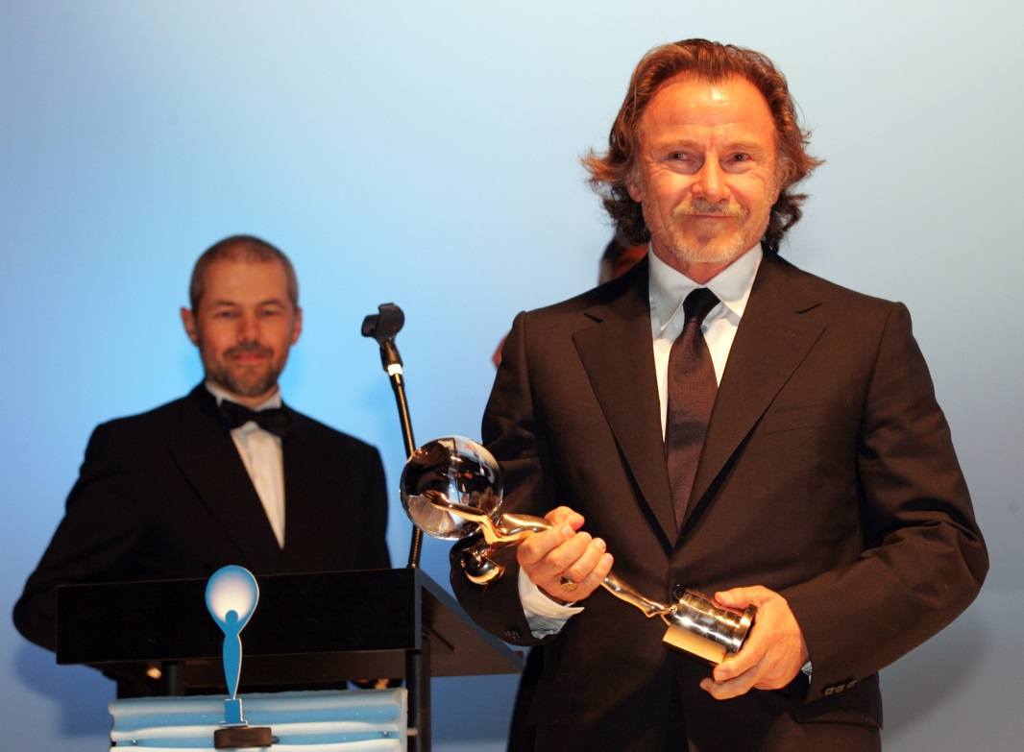
Harvey Keitel grew up in Brooklyn. His professional acting career began in off-Broadway theatres from which he worked his way to Broadway itself, debuting in Death of a Salesman. He came to film thanks to director Martin Scorsese, with whom he made several pictures at the outset of his career, including Mean Streets (1973), Alice Doesn´t Live Here Anymore (1974) and Taxi Driver (1976). In the mid-1970s he starred in Ridley Scott’s historical drama The Duellists (1977), and later joined forces with Scorsese again for the controversial The Last Temptation of Christ (1988), where he played Judas. In 1991, Keitel was nominated for an Oscar for his supporting role in the film Bugsy. In the 1990s he came across another director who significantly influenced his career, Quentin Tarantino, with whom he made the films Reservoir Dogs (1991) and Pulp Fiction (1994). The same period saw a riveting performance by Keitel in Jane Campion’s The Piano (1993) and another collaboration with Ridley Scott in Thelma and Louise (1992). He worked again with Campion in 1999 on her film Holy Smoke.

Harvey Keitel is one of those actors whose filmography includes Hollywood mainstream pictures like U-571 (2000) or Red Dragon (2002), or the action film National Treasure (2004), as well as many independent films that have been buttressed by his performances, for example Bad Lieutenant (1992) by director Abel Ferrara, for which he won the Independent Sprit award for best actor, or Wayne Wang’s Smoke (1995), which won a Silver Bear at the Berlin IFF in 1995. Keitel also played the main role in Ulysses’ Gaze (1995) by director Theo Angelopoulos, which won the Grand Jury Prize at the IFF in Cannes. He very often lends his support to young directors or takes part in producing their films, as was the case with Three Seasons (1999) by the young Vietnamese director Tony Bui. He also has worked with the inventive Wes Anderson as an actor in his films Moonrise Kingdom (2012) and The Grand Budapest Hotel (2014).

Harvey Keitel was not only a guest at the 2004 Karlovy Vary IFF, but was also one of the first figures of world cinema to agree to film one of the festival trailers.

50TH KVIFF TO OPEN WITH FILM STARRING RICHARD GERE
The opening film of this year’s Karlovy Vary festival will be Time Out of Mind by director Oren Moverman and starring Richard Gere in the lead role. Gere himself will present the film, accompanied by the director and actress Jena Malone.
We first encounter the melancholic protagonist of this, the third film by distinctive auteur filmmaker Oren Moverman, just as he is thrown out of his ramshackle apartment and on to the street, with everything he owns in two plastic bags. This powerful story from the life of a homeless person in today’s New York offers a soulful character study of a man whose only hope in an otherwise desperate existence is to try to find reconciliation with his long estranged daughter.
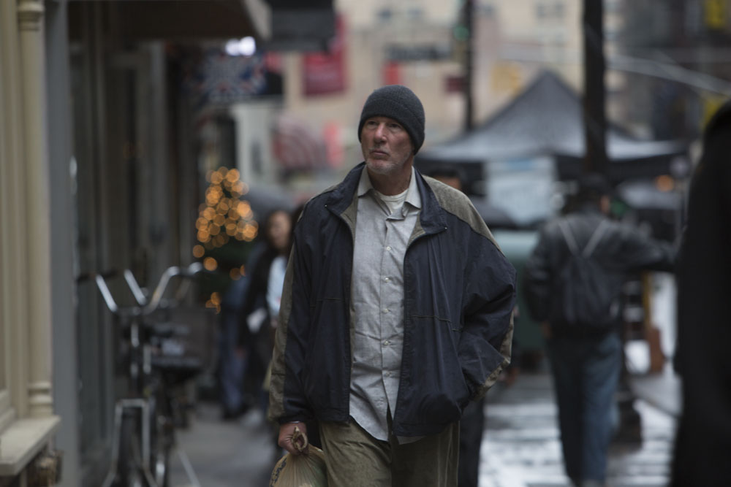
Director, screenwriter, and erstwhile journalist Oren Moverman was born in Israel and settled in New York. He co-authored the screenplays to the films I´m not There (2007) by director Todd Haynes and Married Life (2007) by Ira Sachs. He wrote and directed the film The Messenger (2009), which was screened at the Sundance festival and won a Silver Bear for best screenplay at the Berlinale, followed by the film Rampart (2011), which was co-written with author James Ellroy, and Time Out of Mind (2014), which premiered at this year’s Toronto International Film Festival.

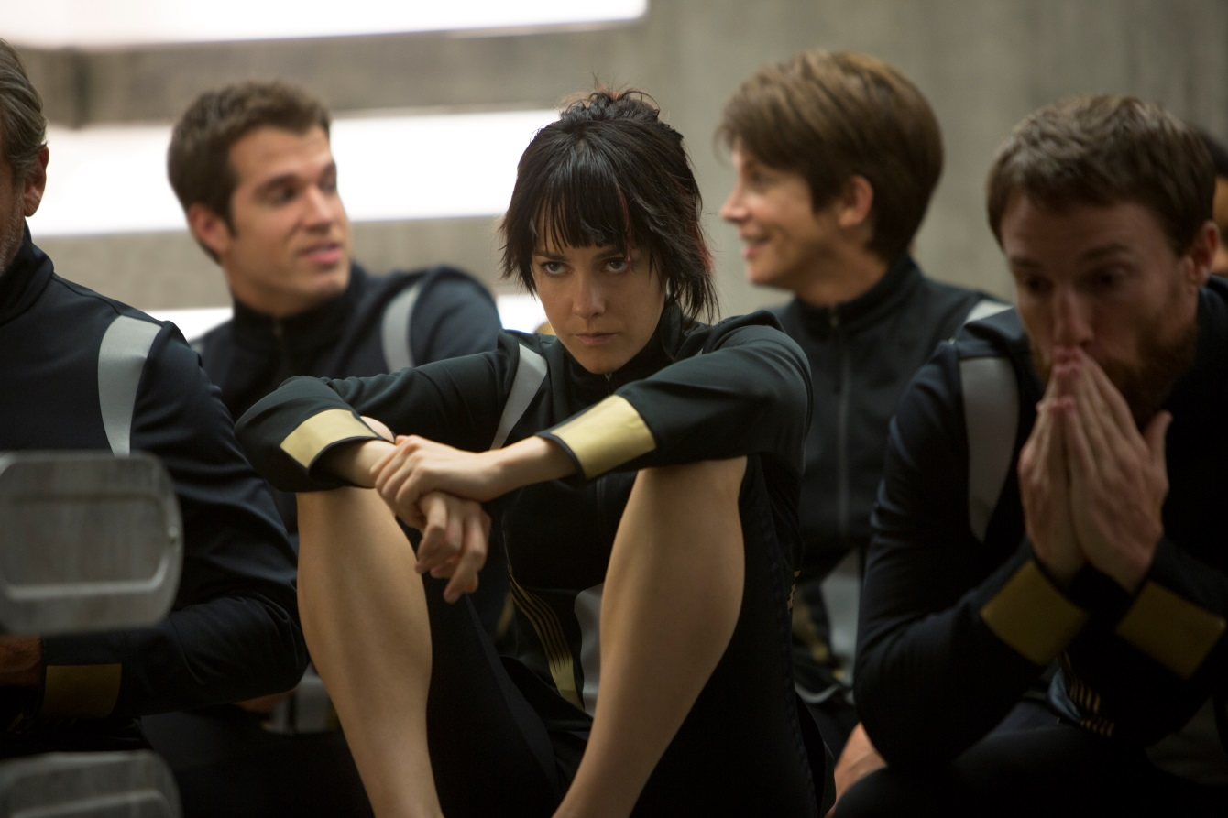
Jena Malone has been captivating audiences since she was a child, starring in Anjelica Huston’s Bastard Out of Carolina (1996), for which she earned an Independent Spirit Award nomination for “Best Debut Performance”, Robert Zemeckis’ Contact (1997) and Chris Columbus’s Stepmom (1998). In 2001, she co-starred in Richard Kelly’s cult classic Donnie Darko. Today she continues to evolve with each new project, having worked with Anthony Minghella on Cold Mountain (2003), Joe Wright on Pride and Prejudice (2005), Sean Penn on Into the Wild (2007), and Paul Thomas Anderson on Inherent Vice (2014), which can be seen at this year’s KVIFF. Malone currently stars as ‘Johanna Mason’ in the wildly popular The Hunger Games franchise.

Photo credit: Bontonfilm

KARLOVY VARY FESTIVAL WILL CLOSE WITH THE FILM SLEEPING WITH OTHER PEOPLE
The closing ceremony of the Karlovy Vary festival will include a screening of one of the hits of this year’s Sundance festival, Sleeping with Other People, presented by the director.
The romantic comedy is a wink across a quarter of a century to Rob Reiner’s cult film When Harry Met Sally, with all its sparkling dialogue and disarming humour. Jake and Lainey spend one crazy night together in a college dorm room, the first such affair for both of them. When they run into each other in New York twelve years later, they find out that in the meantime both of their love-lives have been dogged by problems with infidelity. They make a deal to form a strictly platonic friendship in spite of a strong mutual attraction for the sake of helping each other find a healthy relationship.
Director Leslye Headland debuted with the feature film Bachelorette (2012), which premiered at the Sundance festival and later became one of the most successful distribution films on VOD. Sleeping with Other People is the second film by this talented graduate of the Tisch School of the Arts at NYU.

JAMIE DORNAN AND SEAN ELLIS TO PRESENT NEW FILM AT KVIFF

Actor JAMIE DORNAN and director SEAN ELLIS will be among the guests at the 50th Karlovy Vary IFF, where they will present the new epic co-production film Anthropoid which begins filming in Czech Republic next month. Anthropoid is being produced by US-based studio LD Entertainment.

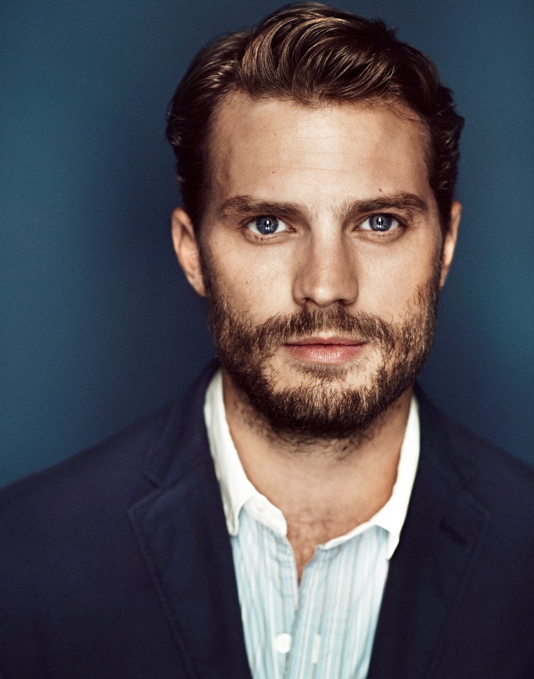
In the film Anthropoid, which deals with the dramatic events around the assassination of Reinhard Heydrich, Dornan will play the role of one of the paratroopers, Jan Kubiš. The film Anthropoid delves into one of the most emotional moments in modern Czechoslovak history.

Photo credit: Adam Whitehead.

UMRIKA TO BE ACCOMPANIED BY FILMMAKERS
European premiere of the heart-warming film Umrika by director Prashant Nair, which won the audience award at Sundance 2015, will be presented at the KVIFF by the director himself and actors Suraj Sharma and Tony Revolori.
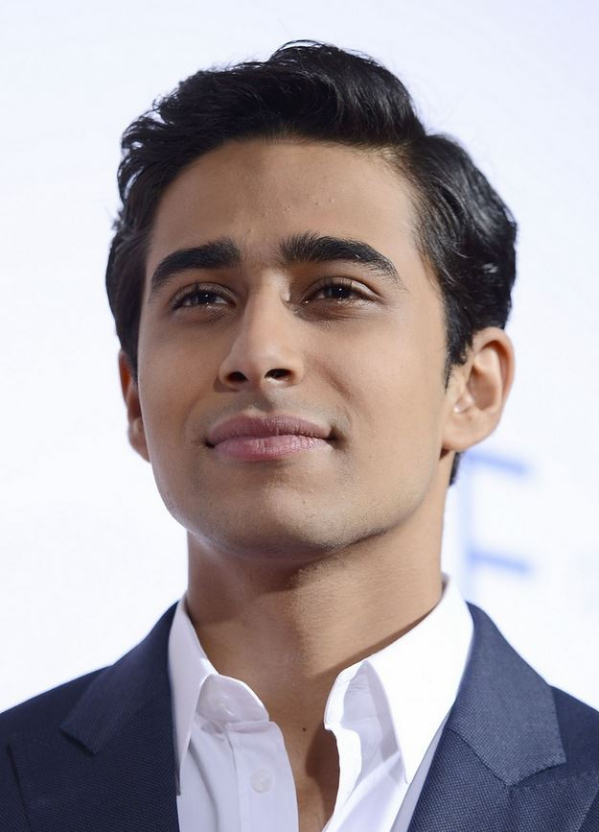
Prashant Nair, director, screenwriter and producer, was born to Malayali parents and grew up in Europe, Asia and Africa. Before settling down as a filmmaker in Mumbai, he worked in Paris, Prague, Berlin and New York. It was there that he took a course in direction and editing at the prestigious NYU, which he says was a formative experience, but adds that his work was influenced most by getting to know many countries and cultures, and by making his own first film. He debuted with the short romantic comedy Max & Helena (2009), followed by the critically acclaimed feature Delhi in a Day (2011), in which a young Briton coming to learn about India encounters the changes that have brought the country major economic growth in the last twenty years.

Suraj Sharma, is a young Indian actor best known to audiences for Ang Lee‘s poetic film Life of Pi (2012), which was awarded four Oscars. Sharma was chosen for the role from 3000 hopefuls. He later performed in the successful, Golden Globe-winning series Homeland.

Tony Revolori is an American actor, versatile musician and lyricist. He has been involved in film since his first small roles at the age of two. His work since then has included a number of television series – Entourage, My Name is Earl, The Unit and Sons of Tucson. The pinnacle of his filmography so far is his performance in the film The Grand Budapest Hotel (2014).

ANDREW RENZI TO PRESENT HIS DEBUT, FRANNY
Director Andrew Renzi returns to Karlovy Vary with his first feature film, Franny.
Director Andrew Renzi studied creative writing with a concentration on screenwriting. As a producer he has collaborated on films such as Afterschool (2008) and Two Gates of Sleep (2010), which were made under the wing of Brooklyn-based production company Borderline Films. He directed the short films The Fort (2011) and Karaoke! (2013), both of which met with success at the Sundance festival. He has also produced and directed music videos for a number of artists. Fishtail, which was in competition at last year’s KVIFF, was his documentary debut. Renzi returns to Karlovy Vary this year with his first feature film, Franny, which stars Richard Gere in the lead role and premiered worldwide in April of this year for audiences at the Tribeca film festival in New York.
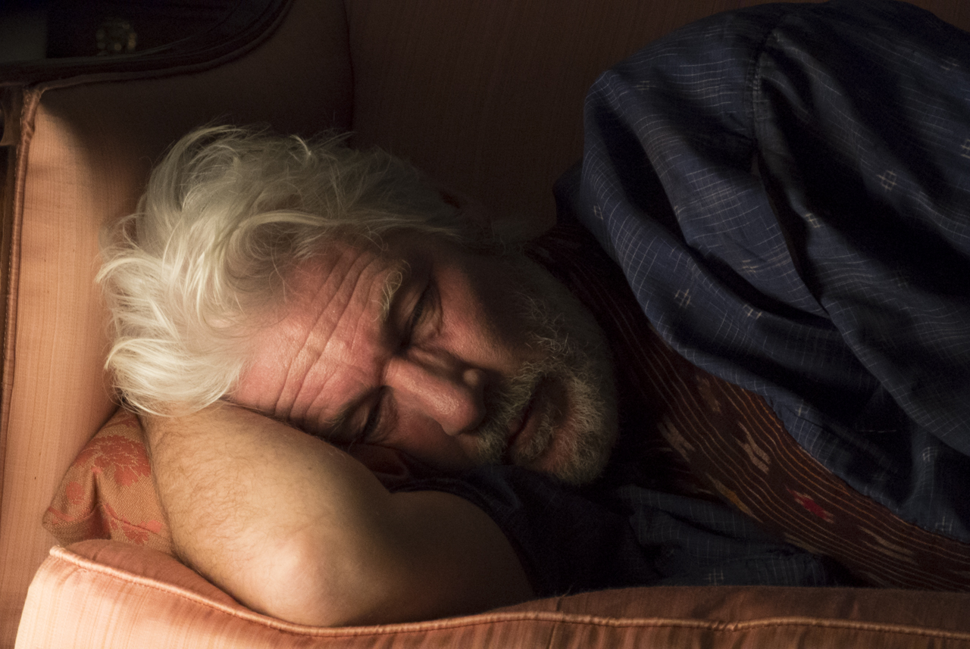

RYAN FLECK IN KARLOVY VARY TO PRESENT MISSISSIPPI GRIND
Director Ryan Fleck will be presenting the poker road movie Mississippi Grind, which he directed in tandem with Anna Boden, for audiences in Karlovy Vary.
Ryan Fleck and Anna Boden have been a filmmaking duo since 2002, when they started writing screenplays together and directed short films and documentaries. Their first two feature films Half Nelson (2006) and Sugar (2008) had their premieres at the Sundance festival. They later won the Gotham and Spirit awards for Half Nelson, with leading actor Ryan Gosling being nominated for an Oscar and an SAG award. The sports drama Sugar was also nominated for Gotham and Spirit awards and won the prize of the American Film Institute. Their third film, It's Kind of a Funny Story, based on the novel by Ned Vizzini, came out in 2010 at the Toronto festival. Anna and Ryan have also collaborated with HBO and Showtime on television series. The team returned to the Sundance festival in January of this year with the road movie Mississippi Grind.

SAVERIO COSTANZO AND ALBA ROHRWACHER TO PRESENT THE FILM HUNGRY HEARTS
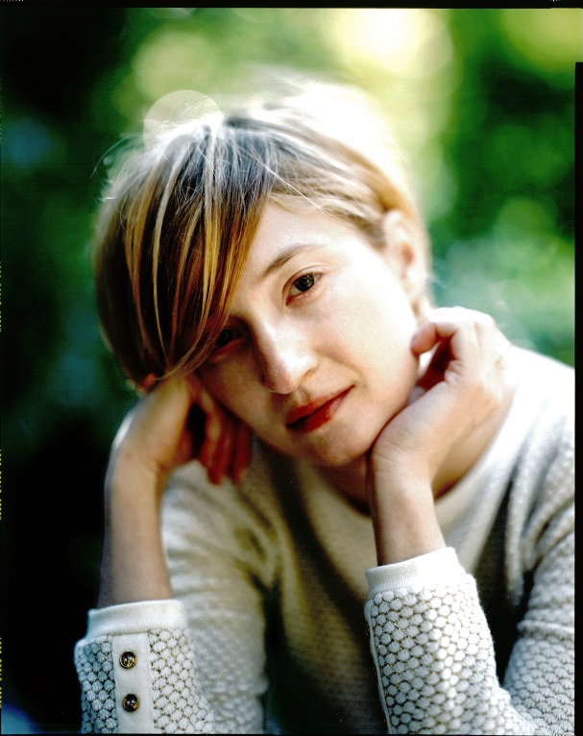
Director Saverio Costanzo and actress Alba Rohrwacher will introduce their film Hungry Hearts in person at the KVIFF.
Alba Rohrwacher started her career with the film L'amore ritrovato (2004). She won her first David di Donatello award for her role in Days and Clouds (Giorni e nuvole, 2007), and her performance as a mentally disturbed daughter in Giovanna's Father (Il papa di Giovanna, 2009) earned her the same prize again. In the same year she was declared a European “Shooting Star”. A great opportunity came for Rohrwacher with the film adaptation of Paolo Giordano’s Italian bestseller The Solitude of Prime Numbers (La solitudine dei numeri primi, 2010).

Another of her many distinctive performances came in the film Come Undone (Cosa Voglio di piú, 2010), after which she had a highly intimate role in The Wonders (Le Meraviglie, 2014), written and directed by her older sister, Alice Rohrwacher. Inspired by the sisters’ own childhood, the film received the Grand Prix at the Cannes Film Festival in 2014. At last year’s international festival in Venice she won the prize for best actress for the film Hungry Hearts (2014) by Italian director Saverio Costanzo. In this year's Karlovy Vary IFF will present her latest film Sworn Virgin (Vergine Giurata, 2015) by debuting director Laura Bispuri, which competed at the Berlinale in February.
Saverio Costanzo studied sociology and communication theory at Sapienza University of Rome (1998). He began working in film while living in New York, where he made the documentary Caffè Mille Lucci, Brooklyn, New York (1999). His feature-film debut, Private (2004), took the Golden Leopard at the Locarno IFF and a David di Donatello for Italy’s best new director. His next film, In Memory of Me (In memoria di me, 2007) was included in the main competition of the IFF in Berlin and in the Focus on New Italian Directors section at the Karlovy Vary IFF. In 2011, the Karlovy Vary festival also screened his drama The Solitude of Prime Numbers in its Horizons section.

GEORGE A. ROMERO WILL PERSONALLY PRESENT TALES OF HOFFMANN
Well-known American screenwriter, director and producer George A. Romero, creator of cult horror films beginning with the legendary Night of the Living Dead, will be a guest at the 50th KVIFF where he will personally present one of the most admired works of the celebrated writer-director duo Michael Powell and Emeric Pressburger, Tales of Hoffmann (1951). The matchless film adaptation of Jacques Offenbach’s opera will be screened in a newly restored version. George A. Romero is one of the greatest admirers of this cinematic masterpiece.

International Juries
Statutory Juries:
Grand Jury

Tim League
American cinema operator and distributor. In 1997 he and his wife Karrie founded the renowned theater chain Alamo Drafthouse. He also cofounded Fantastic Fest, the largest genre film festival in the United States. In 2010 he launched Drafthouse Films, a distribution label committed to releasing provocative, visionary, and artfully unusual films onto the American market (e.g. Four Lions, A Field in England, Nothing Bad Can Happen, and Nick Cave: 20,000 Days on Earth).
Angelina Nikonova
Russian director, screenwriter, and producer. At age 17 she moved to New York, where she graduated from the School of Visual Arts in 2001 with the award-winning short Isosceles. In 2005 her first feature-length documentary Flyover Country had a theatrical run in Moscow. In 2011 she debuted as a feature film director with Twilight Portrait, co-written by its lead actress Olga Dihovichnaya. The picture premiered in Venice’s Giornate degli autori section, subsequently winning 18 awards at top festivals worldwide. Her second feature Welkome Home competed at last year’s Karlovy Vary IFF. She and Dihovichnaya also run the 2morrow International Festival of Independent Films in Moscow.
Ólafur Darri Ólafsson
Actor and producer with dual nationalities who splits his time working in Iceland and the USA. He has worked with many Icelandic film directors, including Baltasar Kormákur (The Deep), Marteinn Þhorsson (XL, Best Actor Award at KVIFF 2013), and Ragnar Bragason (Children and Parents). In the United States he has appeared in the films of such directors as Steven Spielberg, Ben Stiller, Jonathan Demme, Charlie Kaufman, and Cary Fukunaga. Upcoming projects include the ten-part Icelandic series “Trapped,” the action fantasy film The Last Witch Hunter, and Spielberg’s adaptation of the Roald Dahl tale The BFG.

Hengameh Panahi
Renowned producer and one of the most respected international sales agents. She is founder and president of Celluloid Dreams, The Director’ Label, a leading worldwide sales company. Long-term she has cooperated with director Jafar Panahi (Golden Bear for Taxi at this year’s Berlinale), and also with Jacques Audiard (Palme d’Or at this year’s Cannes festival for Dheepan), whose film A Prophet she also produced. Her company backed the pictures The Mourning Forest, Bullhead, Funny Games (US version), and Lebanon. She has cooperated as producer with Jia Zhangke, Alexander Sokurov, Apichatpong Weerasethakul, Todd Haynes, Marco Bellocchio, and many others. In 2007 she cofounded the first worldwide social- network driven VOD platform: The Auteurs (renamed MUBI).
Ondřej Zach
Senior Vice President for program HBO Europe and head of programming and acquisitions for HBO Europe in the Czech Republic. He studied library science and later film science at Charles University, and since 1992 he has worked as a film journalist. In 1994-1998 he worked as a KVIFF programmer. Since 1998 he has headed up program acquisitions for TV Nova, later working for AQS to secure the purchase of programs for TV Nova, TV Prima, and Slovakia’s TV Joj, also founding AQS’s Magic Box video distribution company and Bioscop film distribution. He has worked with HBO since 2006, and since 2008 he has organized the purchase of content and programming for all regional channels and HBO on-demand services in Central Europe and the Netherlands.
East of the West Jury

Gaby Babić
Festival organizer. She studied in her hometown of Frankfurt and in Paris, graduating in theater, film, and media studies, political science, and German literature. In 2005-2007 she worked at the Goethe Institute in Sarajevo as a program coordinator, and in 2007-2008 she was involved in the research project “Visual Cultures in Serbia” at the University of Konstanz. Since 2008 she has been curator and cultural manager for several film festivals and cultural institutions. Beginning in September 2010 she became the director of Wiesbaden’s goEast festival of Central and Eastern European Film.
Alexis Grivas
Renowned Greek journalist, festival programmer, and cameraman. After studying in Athens and at Paris’s IDHEC, he began working as a director of photography (1967), at the same time contributing to major film magazines and newspapers in France, Mexico, and Greece. He is a representative-at-large and adviser for the Mexican Film Institute (IMCINE), and a cofounder of the Guadalajara International Film Festival. He is also the Berlinale delegate for Mexico and Greece (2001 to the present). In 1998-2011 he was in charge of the foreign press department and of international program coordination at the Thessaloniki IFF. He represents Greece at Eurimages, and has been in charge of the Greek Film Center since March 2015.
Tomáš Luňák
Czech director. He studied animation at Zlín Film School and at Prague’s Film Academy (FAMU). His puppet film Acrobat (2000) screened at Annecy, Hiroshima, and dozens of other film festivals. At Eallin Animation Studios he directed music videos for the bands The Ecstasy of Saint Theresa, Priessnitz, and Here. His feature debut was an adaptation of the comic book series Alois Nebel (2011). Shot using the rotoscoping technique, the film premiered at the Venice IFF, and in 2012 it took the European Film Academy Award for best animated movie. He is a member of the Babice sports club.
Ivan I. Tverdovsky
Russian director who graduated from Moscow’s Gerasimov Institute of Cinematography (VGIK) in 2011. His documentaries have earned accolades at Russian and international festivals, among them Pianism (2012) and the short docs As If Waiting for a Bus (2009) and Space Dog (2013). He works as curator of short Russian films at the Moscow IFF. His feature debut Corrections Class won last year’s East of the West competition at KVIFF, and went on to win prizes at Cottbus, Marrakesh, Seattle, and Lecce.
Olena Yershova
Ukrainian film producer living in Turkey. She works for the Molodist festival in Kiev and the Eurasia Film Market in Turkey. She executive produced Sergei Loznitsa’s My Joy, which competed at Cannes in 2010. A year later she founded her own production company, Tatofilm. In 2013 she produced Levan Koguashvili’s Blind Dates, an award-winning Georgian film that screened at Toronto, the Berlinale, and KVIFF. That same year she produced Love Me, the first Ukrainian-Turkish co-production. She is currently finishing work on the Turkish film Motherland by Senem Tüzen.
Forum of Independents Jury

Katrin Gebbe
German filmmaker. She launched her career shooting experimental films at the Academy of Visual Arts and Design in the Netherlands and at Boston’s School of the Museum of Fine Arts. In 2008 she graduated with honors in direction from the Hamburg Media School. During her studies she directed award winning shorts, including Şoreş & Şîrîn. Nothing Bad Can Happen (Tore tanzt), her writer-director feature debut, premiered in Cannes’ Un Certain Regard in 2013 and was subsequently shown at KVIFF. She currently lives and works in Hamburg.
Michael Málek
Programmer at Czech Television’s Center for Acquisitions. Having gained an economics degree he then undertook commercial transactions for Czechoslovak Filmexport. At the beginning of the 1990s he was Prague correspondent for Variety magazine. He has worked for several distribution companies and now, alongside his work in acquisitions for Czech TV, he is involved in film history and publicist work as well. He also lectures at events held by the Association of Czech Film Clubs and other organizations.
Yeo Joon Han
Malaysian director. His first short film Adults Only won a Special Mention at the 2006 Venice IFF. A chance meeting and conversation there with a programmer from KVIFF inspired the opening scene of his first feature. Sell Out! premiered two years later at Venice, winning the Altre Visioni Award and earning Best Film from the Settimana della critica. Having made a film about selling out, he then did exactly that: he shot a horror film, cowrote the script for a Korean comic-book adaptation, and made TV commercials. He’s now trying to buy his soul back by making a personal film with a Digital Bolex camera and an unlucky intern from Bulgaria.

Documentary Film Jury

Paolo Bertolin
Italian festival programmer, film critic, and producer. He joined the Venice International Film Festival in 2008 as a member of the selection committee (2008-2009) and regional consultant (2008-2015). He also worked or still works for the IFFs in Beijing, Mumbai, Torino, Rotterdam, Nyon, and Bratislava, as well as for Cannes’ Critics’ Week and the Doha Film Institute. He coproduced the Vietnamese picture Big Father, Small Father and Other Stories (Berlinale 2015 competition) and Chitrashala (Berlinale Shorts 2015).
Teodora Ana Mihai
Romanian filmmaker who left her country in 1989 to join her parents who had fled to Belgium. She discovered her love for cinema as a teenager and went on to study film at Sarah Lawrence College in New York. Last year she turned out the award-winning documentary Waiting for August (Best Documentary over 30 Minutes at KVIFF 2014). She is now working with Mexican writer Habacuc A. De Rosario on two complementary films: a docu-fiction about growing up on the Mexico-US border and a documentary following a mother’s extraordinary transformation from housewife to vengeful militant after her teenage daughter is murdered by the Zetas crime syndicate.
Ivana Pauerová Miloševič
Sarajevo-born director and script developer living in the Czech Republic. She graduated from Charles University’s Faculty of Humanities and from Prague’s Film Academy (FAMU). Her documentaries include Never Been Better, on the situation in postwar Bosnia, and Ladies in White, about the wives, mothers, and sisters of Cuban dissidents. From 2003 to 2012 she headed up the Ex Oriente Film workshop for the Institute of Documentary Film and the East European Forum. She works as an external lecturer for FAMU. In 2009 she was elected to the executive committee of the European Documentary Network (EDN). Since 2012 she has cooperated with Czech Television in the roles of project supervisor and script developer for documentary films and series.

Nonstatutory Juries:

FIPRESCI Jury
Swapan Kumar Ghosh
Radovan Holub
Eva Peydró
Pamela Cohn
Srđan Vučinić
Ecumenical Jury
Michael Otřísal
Vít Poláček
Lothar Strüber
Rita Weinert
FEDEORA Jury
Ronald Bergan
James Evans
Gidi Orsher
Europa Cinemas Label Jury
Erika Borsos
Caroline Dragacci
David O’Mahony
Jens Schneiderheinze

RENOWNED DIRECTORS PRESENT THEIR FAVOURITE FILMS IN KARLOVY VARY
The celebrations around the 50th Karlovy Vary IFF will include an opportunity for festival audiences to encounter a special section entitled Six Close Encounters. For the programme, six international directors who share a history with the Karlovy Vary IFF present one of their favourite films.
“It is extremely important to us that we maintain long-term relationships with filmmakers whose work we follow continuously, often from the beginning of their careers, which in many cases were launched at the Karlovy Vary International Film Festival,” says KVIFF artistic director Karel Och.
With this in mind, the Karlovy Vary IFF asked six prominent directors and friends to select and personally present a favourite film that played a fundamental role in defining their own styles on filmmaking.
The following six directors contributed to the Six Close Encounters showcase: Mark Cousins, Kim Ki-duk, Sergei Loznitsa, Luis Miñarro, Michael R. Roskam and Sion Sono.
Mark Cousins is a Northern Irish filmmaker, writer, curator and traveller whose films regularly appear in the Karlovy Vary IFF programme. The festival has screened his documentary The First Movie (2009), his monumental, 15-hour documentary project The Story of Film: An Odyssey (2011) and his poetic reflection What is This Film Called Love? (2012). Also presented at the festival was his original project A Story of Children and Film (2013) and Life May Be (2013), in which Cousins and respected Iranian artist Mania Akbari communicate together via “film letters”. This year Mark Cousins’ work will be represented in the Documentary Films Competition with a distinctive homage to his hometown I am Belfast (2015).
For the Six Close Encounters section, Mark Cousins chose the Iranian-French film A Moment of Innocence (Nun va Goldoon, 1996) by one of the leading directors of the Iranian new wave, Mohsen Makhmalbaf.
The talented and versatile Korean director Kim Ki-duk has been associated with the Karlovy Vary IFF for nearly twenty years now. In that time, nearly all of Kim Ki-duk’s films have been screened here. In 2002, the director attended the festival for the very first retrospective devoted to his work. At the 38th KVIFF the film The Coast Guard (Hae anseon, 2002) appeared in the Official Selection, in 2006 the festival opening ceremony showcased the world premiere of his film Time, with the director himself present in both cases. And even in recent years, when Kim Ki-duk’s work has garnered awards at a number of awards at international festivals after a creative break, audiences here continue to appreciate his films. On the programme at this year’s KVIFF is Kim Ki-duk’s latest film, Stop (2015), again as a world premiere.
In the Six Close Encounters section Kim Ki-duk will present the film Poetry (Shi), directed by his colleague and countryman Lee Chang-dong in 2010, the same year that the filmmaker was a member of the KVIFF main jury.
Sergei Loznitsa, a Belorussian director based in Germany, first took part in the Karlovy Vary IFF in 2001 when his feature-length documentary The Settlement (Poselenie) received a special mention. Two years later the same distinction went to his documentary short Portrait (Portret, 2002). In 2007 he won the documentary films up to 30 minutes category with the film Artel. His work is regularly screened at the Karlovy Vary IFF, including his feature-film debut My Joy (Schaste moe, 2010) and the film In the Fog (V tumane, 2012), both of which were also selected for the competition in Cannes, his documentary dedicated to the dramatic events in Ukraine, Maidan (2014), and his short experimental work from 2013 Letter (Pismo). In this year’s Imagina section we will be presenting the director’s unique portrait of a disappearing place, Old Jewish Cemetery (2014).
Seregej Loznitsa will show director Kira Muratova’s magnum opus, The Asthenic Syndrome (Astenicheskiy sindrom, 1989). This raw epic about the state of Soviet society during the spread of perestroika won the Special Jury Prize at the 1990 Berlinale and is indisputably one of the pinnacles of Soviet cinematography.

Luis Miñarro is one of the most highly-regarded European producers of independent cinema. In 2010 he was awarded the Crystal Globe for Best Film in Karlovy Vary for The Mosquito Net (La Mosquitera, dir. Agustí Vila). He is the founder of the production company Eddie Saeta S. A. which has given rise to the films of a number of outstanding European filmmakers. As for his work as a director, KVIFF presented the world premiere of Miñarro’s film Familystrip in 2009, and the remarkable documentary 101: Manoel de Oliveira as Seen by Luis Miñarro in 2012. Last year, Luis Miñarro was the chairman of the KVIFF international jury and also presented his feature directorial debut Falling Star (Stella cadente, 2014).

For his contribution to the section Miñarro chose the Orson Welles’ legendary 1958 film noir Touch of Evil, in which the director also played one of the lead roles.

Michaël R. Roskam studied painting at the LUCA School of Arts in Brussels and started with film in 2002, since which time his shorts have been rapturously received at festivals. His feature-length debut, Bullhead (Rundskop, 2011), which premiered at the Berlinale and was later included in the programme of the Karlovy Vary IFF, was nominated for an Oscar for Best Foreign Language Film. This year’s programme includes Roskam’s latest work, The Drop (2014) which was shot in the United States and won the Best Screenplay award at the San Sebastian Film Festival.
The Belgian director, too, reached for a title from the film noir shelf, selecting the film adaptation of Auguste Le Breton’s Rififi (Du rififi chez les hommes, 1955) by director Jules Dassin.
Japanese director Sion Sono has progressively earned his reputation as one of the most nonconformist contemporary filmmakers from his country, for which reason his films are sought after by festivals including Cannes, Venice, Berlin and Toronto. Audiences at the Karlovy Vary IFF have had the opportunity to see his films Noriko's Dinner Table (Noriko no šokutaku, 2005), which was selected for the main competition and received a Special Jury Mention, Love Exposure (Ai no mukidashi, 2008) and Guilty of Romance (Koi no cumi, 2011). At this year’s Karlovy Vary festival we will be presenting Sono’s hip-hop opera Tokyo Tribe (2014).
Sion Sono will be showing Karlovy Vary audiences his favourite film, Babe (1995), Chris Noonan’s family comedy which was nominated for seven Oscars and received the award for Best Special Effects.

INDUSTRY EVENTS AT THE 50th KARLOVY VARY IFF 2015
Sunday, July 5, 2015
CAREER INSIGHTS FOR THE INTERNATIONAL FILMMAKER: UNDERSTANDING AND OVERCOMING THE HURDLES OF HOLLYWOOD (EN)
1.00 pm – 4.00 pm, Grandhotel Pupp, La Belle Epoque Restaurant
This year’s informal panel will take an interactive approach to advising international filmmakers on how to push forward their film and television projects within the Hollywood system, including an active conversation about how best to approach collaborating with Hollywood stars, directors, producers, financiers or distributors. An experienced group from the United States that includes a financier, sales agent, producer, and filmmaker perspective will give in depth answers to audience questions about practical problems, and share their experiences from breaking into "the system". Hopefully this discussion will provide international filmmakers valuable information to use on their projects, and also create potential for collaboration that is useful for parties on both sides of the ocean.
Speakers: Milan Popelka, COO at FilmNation Entertainment; Andrew Renzi, director of the film Franny, Douglas E. Hansen, President of Endgame Entertainment Company and CEO of Endgame Releasing Company. Moderated by producer, screenwriter, and film journalist Tomáš Baldýnský.
We welcome film professionals, journalists, and the general public.
As seating capacity is limited, please confirm your attendance by sending your name, company, and position by July 4 at maleckova@kviff.com.

EUROPEAN CONTENTS IN DIGITAL ERA. TOWARDS A MODERNISED COPYRIGHT FRAMEWORK. WHAT IS AT STAKE? (CZ / EN / DE)
4.30 pm – 6.00 pm, Blue Lounge, Lázně III
Nearly half of Europeans fail to use streaming services from their own country while on holiday abroad because of geo-blocking. Both technology and how society makes use of it have evolved significantly since the existing legislation on copyright was drafted. It affects not only creators and consumers but also the whole value chain of the audio-visual industry. New attempts to modernise copyright rules on EU level are now on the table. What is at stake of this reform? Is it ambitious enough and how it affects the distribution models?
Speakers: Mr. Pavel Svoboda, Chair of the Committee on Legislative Affairs, European Parliament; Mr. Bogdan Wenta, Culture and Education, European Parliament; Mr. Petr Ostrouchov, expert on copyright law, and other experts. Moderated by Ms. Doris Pack, LUX Prize coordinator, former Chairwoman of the Committee on Culture and Education, European Parliament.
Debate organized by the LUX Film Prize of the European Parliament and Creative Europe Desk Czech Republic-MEDIA, in partnership with KVIFF and Europa Distribution.
Registration by July 4 and further information at media@kreativnievropa.cz

LUX FILM PRIZE UNVEILS THE TOP 10 FILMS (EN)
6.30 pm – 8.00 pm, Terrace, Hotel Thermal
In the framework of Karlovy Vary IFF, the European Parliament unveils the selection of 10 films nominated for the 2015 LUX Film Prize. On this occasion, the Audience Mention of last edition will be also announced.
The LUX Film Prize was established in 2007 in order to support the European film industry, subtitling the most significant European co-productions into all official European Union languages, propelling them beyond their national market. In doing so, the European Parliament supports cultural diversity, as it brings LUX Prize films to audiences across Europe and encourages debate on the issues they raise. Out of the ten, 3 finalists are subtitled into 24 European languages and screened across Europe.
Registration by July 4 and further information at luxprize@ep.europa.eu

Monday, July 6, 2015
INDUSTRY WORKSHOP:

IS THERE DEMAND FOR ON DEMAND? WHAT LIES BENEATH THE DIGITAL MARKET? (EN)
10.00 am – 12.00 noon, Cinema, Lázně III
In the frame of the debates on VOD and the fragility of online barriers, Europa Distribution, in partnership with KVIFF and the LUX Prize has set up a panel to enable an in-depth evaluation of the current VOD market and digital opportunities and threats. What is the reality of the online market today? How about film diversity, accessibility and circulation? What are the consequences of the Digital Single Market applied to film?
Professionals from the entire film value chain will share their experiences and recent learning to assess what the European independent film industry has in store for the close future.

WORKS IN PROGRESS 2015 (EN)
1.30 – 5.00 pm, Congress Hall, Hotel Thermal
Every year, producers and filmmakers from Central and Eastern Europe, the Balkans, Turkey and the countries of the former Soviet Union present their latest feature production at KVIFF’s Works in Progress. This one-day presentation, intended for international sales agents, distributors, co-producers, and festival programmers, offers a selection of 15 quality films whose premieres are expected after July 2015. The films must be recently completed or in postproduction, and lack an international sales agent. The most promising project, selected by the International Jury, will receive an award of 10,000 euros in services from Barrandov Studios, the event’s partner.

Tuesday, July 7, 2015
PITCH & FEEDBACK (EN)
10.00 am – 1.00 pm, Barrandov Studios Villa (Becher´s Villa)
A presentation of Czech and Slovak film projects in development with a potential for international co-productions which will receive professional feedback by experts from the international film industry. The goal is to create an effective platform for the selected projects and to enhance networking possibilities between the Czech and Slovak filmmakers and the international film industry attending Karlovy Vary IFF.
Pitch & Feedback is organized by Czech Film Center, Slovak Film Institute and Karlovy Vary IFF in cooperation with Midpoint and Barrandov Studios.

DOCU TALENTS FROM THE EAST 2015 (EN)
2.00 – 4.00 pm, Barrandov Studios Villa (Becher´s Villa)
Docu Talents from the East 2015 will introduce the most remarkable creative documentary projects from Central and Eastern Europe in the stage of production or post-production. Directors and producers of twelve selected feature-length documentaries will introduce their projects planned for theatrical distribution in the period from August 2015 to July 2016 in eight-minute presentations.
Docu Talents from the East is organized by the Jihlava International Documentary Film Festival, in cooperation with Karlovy Vary IFF.

Wednesday, July 8, 2015
STATE CINEMATOGRAPHY FUND, 2ND YEAR (CZ)
2:00 pm – 3:30 pm, Blue Lounge, Lázně III
The State Cinematograph Fund has completed yet another year of functioning according to the new Cinematography Act. What is the current economic situation, what are some of the changes and obstacles in the institution, which has been recently cut loose to stand on its own two feet? A traditional panel, with Helena Bezděk Fraňková, will provide a more detailed look at setting a complex model for cinema financing, as well as the day-to-day administrative obligations that have an impact on both Czech cinematography and the cinema industry.

Thursday, July 9, 2015
TORINOFILMLAB:
INDONESIAN CINEMA & CENSORSHIP – THE PERSONAL JOURNEY OF EDWIN (EN)
10:30 am – 12:00 noon, Blue Lounge, Lázně III
TFL FrameWork Alumnus Edwin (with Postcards from the Zoo – first Indonesian film ever to be selected for Berlinale’s main competition in 2012) will share his personal experiences of censorship making films in Indonesia. The filmmaker will elaborate on how, besides violating human rights, censorship reflects the old Indonesian rooted corrupt, unorganized system, and how the permanence of film censorship in the country regime after regime has affected people unconsciously to the point of self-censoring their thoughts.
Prior registration is mandatory. Please, confirm your attendance and reserve a place by July 8 at maleckova@kviff.com.

TORINOFILMLAB:
THE CIRCUIT OF EXCESS: FILM INDUSTRY, TABOOS AND ONLINE CONVERSATIONS (EN)
4:00 pm – 5:00 pm, Blue Lounge, Lázně III
TFL Audience Design Alumnus Nicolò Gallio will share the results of an ongoing research on transgressive & offensive cinema – focusing on cannibal movies.
This talk is part of a project run by Nicolò Gallio and Juan Morali, in collaboration with the agency Sentisis. It focuses on transgression and taboos as cultural categories, and includes a case study that introduces the provisional findings of a qualitative monitoring of online conversations on social media generated around transgressive content.

Friday, July 10, 2015
TORINOFILMLAB: FILM FESTIVALS AT THE MERCY OF POLITICS (EN)
11.00 am – 12.00 noon, Blue Lounge, Lázně III
A conversation with Azize Tan, director of Istanbul Film Festival.
Film festivals, widely recognized all over the world as realms of freedom of artistic expression, are increasingly on the threat of political pressures. Examples of interference have multiplied recently, with the executive director of Busan forced to step down last October or, at the very moment, the Minister of Culture threatening to reconsider public funding for the Jerusalem Film Festival. Azize Tan will come back to the events that shook the Istanbul Film Festival last April, when Turkish filmmakers pulled out their films over censorship row.
WHAT NEXT? WILL STUDIES LEAD THE WAY FOR CZECH CINEMA? (CZ)
2.00 pm – 3.30, Blue Lounge, Lázně III
Two extensive studies were published this year. The first, carried out by APA, provides an insight into the habits of viewers and their perception of Czech film production. The second study, conducted by SFK, focuses on film development.
The Ministry of Culture has drafted an amendment to the Media and Audiovisual Services Act that will provide a new source of funding for SFK from the state budget. Where is funding needed most? How can it help Czech cinematography to be more attractive to the viewers and successful at international festivals? Is lack of funding the only problem of local film production? Do the ambitions of local filmmakers exceed their skills? Or is Czech film in need of a strategy that would keep moviegoers interested in this digital age.
TORINOFILMLAB: SHALL IT BE FORBIDDEN TO FORBID? (EN)
4.00 pm – 5.00 pm, Blue Lounge, Lázně III
A talk with Peter Kerekes, documentary filmmaker, about his film project Censors.
Thought-provoking and irreverent Slovak filmmaker Peter Kerekes (A Cooking History, Velvet Terrorists) is embarking on a new journey exploring the important daily decisions that small people part of big systems have to take. Kerekes’s attention will be targeted at censors, the very last “manual workers” in an era of security softwares. Censors intends to be a very “un-revolutionary” film, insisting on the importance of setting borders and social value of censorship. Yet, is it even possible to make an apolitical film about censorship? Hopefully, the question will stir vivid debates in the audience.

KARLOVY VARY IFF ANNOUNCES WORKS IN PROGRESS LINE-UP
Monday, July 6, 2015, 1.30 – 5.00 pm, Congress Hall, Hotel Thermal
Last year’s winner Goat (Koza) was premiered at the Berlinale as well as the Russian film The Gulls (Chaiki), the Turkish film Ivy (Sarmaşık) was selected for the Sundance Film Festival. The Romanian film Self-Portrait of a Dutiful Daughter (Aventurile unei fete cuminti) was screened at festivals in Rotterdam and Bucharest.
The films Goat, Ivy and The Gulls can be seen at Karlovy Vary IFF together with other films from last year’s Works in Progress selection. Main competition – Red Spider (Czerwony pająk), East of the West Competition – Journey to Rome (Cesta do Říma), Ivy (Sarmaşık); Czech films: – Us 2 (My 2), Little from the Fish Shop (Malá z rybárny).
Countries in 2015 selection: Belarus, Bosnia and Herzegovina, Monte Negro, Czech Republic (2), Estonia, Croatia (2), Latvia, Poland (3), Romania, Greece (2), Slovakia (3), Slovenia, Turkey.

Ana Yurdu / Motherland
Director: Senem Tüzen
Turkey, 98 min, debut
Ausma / Dawn
Director: Laila Pakalnina
Latvia, Estonia, Poland, 90 min
Eva Nová
Director: Marko Škop
Slovakia, 115 min
Houston, we have a problem!
Director: Žiga Virc
Slovenia, Croatia, Německo, Katar, debut, 85 min
Igla ispod praga / The Black Pin
Director: Ivan Marinovic
Monte Negro, 100 min
Królewicz Olch / The Erlprince
Director: Kuba Czekaj
Poland, 100 min
Mars
Director: Benjamin Tuček
Czech Republic, 80 min
Nima / Thread
Director: Alexandros Voulgaris (The Boy)
Greece, 92 min
Orizont
Director: Marian Crisan
Romania, 90 min
Park
Director: Sofia Exarchou
Greece, 90 min
PUNK JE HNED! / PUNK IS NOT DEAD!
Director: Juraj Šlauka
Slovakia, debut, 75 min
Rabih (ربيع) / Tramontane (mimo soutěž)
Director: Vatche Boulghourjian
Libadon, Francie, 100 min, debut
Rosa / Dew
Director: Jan Balej
Poland, Bosnia and Herzegovina, Croatia, 100 min
Vlk z Královských Vinohrad / Wolf of Royal Vineyard Street
Director: Jan Němec
Czech Republic, Francie, Slovakia, 75 min
Между небом и землёй / Between Heaven and Earth
Director: Dzmitry Dziadok
Belarus, 120 min

CAREER INSIGHTS FOR THE INTERNATIONAL FILMMAKER: UNDERSTANDING AND OVERCOMING THE HURDLES OF HOLLYWOOD
Sunday, July 5, 2015, 1.00 pm – 4.00 pm, Grandhotel Pupp, La Belle Epoque Restaurant
This year’s informal panel will take an interactive approach to advising international filmmakers on how to push forward their film and television projects within the Hollywood system, including an active conversation about how best to approach collaborating with Hollywood stars, directors, producers, financiers or distributors. An experienced group from the United States that includes a financier, sales agent, producer, and filmmaker perspective will give in depth answers to audience questions about practical problems, and share their experiences from breaking into "the system". Hopefully this discussion will provide international filmmakers valuable information to use on their projects, and also create potential for collaboration that is useful for parties on both sides of the ocean.
Speakers: Milan Popelka, COO at FilmNation Entertainment; Andrew Renzi, director of the film Franny, Douglas E. Hansen, President of Endgame Entertainment Company and CEO of Endgame Releasing Company. Moderated by producer, screenwriter, and film journalist Tomáš Baldýnský.
We welcome film professionals, journalists, and the general public.
As seating capacity is limited, please confirm your attendance by sending your name, company, and position by July 4 at maleckova@kviff.com.
Milan Popelka
Milan Popelka is the Chief Operating Officer at FilmNation Entertainment, a leading independent entertainment company focused on the sales representation of international film & television rights as well as the internal development, production, and financing of feature films. Popelka’s responsibilities include overseeing all day-to-day operations and finance for the company. FilmNation is currently in production on Denis Villeneuve’s Story of Your Life starring Amy Adams and John Lee Hancock’s The Founder, which will star Michael Keaton. International sales credits include: Academy Award winning The Imitation Game starring Benedict Cumberbatch; Best Picture Academy Award Winner The King’s Speech; Alexander Payne’s six-time Academy Award nominated Nebraska starring Bruce Dern; among others. Prior to joining FilmNation, Popelka worked in the Independent Finance Group at Creative Artists Agency (CAA) and served as a consultant in the entertainment practice of McKinsey & Company. He received a B.A. in Economics from Harvard University.
Andrew Renzi
Andrew Renzi recently completed his first narrative feature film Franny starring Richard Gere, Dakota Fanning, and Theo James. Prior to that, Andrew directed two short films The Fort (Sundance '12) and Karaoke! (Sundance '13), and the award winning 60 minute western documentary Fishtail, which was acquired by Netflix in 2015. Recently, Andrew worked with writer/director Sean Durkin to co-write the Janis Joplin biopic. As a producer Andrew has worked on several films including Afterschool (Cannes '08) and Two Gates of Sleep (Cannes '10). Andrew started his film career by blending mango lasses for Wes Anderson.
Douglas E. Hansen
Douglas E. Hansen serves as the President of Endgame Entertainment Company as well as the Chief Executive Officer of Endgame Releasing Company, which was founded in 2013 and launched with $100M in capital to finance P&A (Prints and Advertising) for wide release films (1800+ screens) distributed by the major and mini-major studios. Mr. Hansen has primary responsibility for sourcing, structuring and negotiating the Company’s investments and financing. Mr. Hansen has been a financier and adviser to the entertainment industry for more than twenty five years and has been an Executive Producer on over 20 feature films and two television series. Endgame has produced and/or financed a variety of film, television, and live stage productions across a wide range of genres including Tarsem Singh’s upcoming action-thriller Selfless starring Ryan Reynolds, Rian Johnson’s sci-fi thriller Looper and Steven Soderbergh’s Side Effects, as well as the Oscar-nominated An Education and Hotel Rwanda, and titles including Harold and Kumar go to White Castle, Lord of War, and I’m Not There. Prior to the founding of Endgame with James D. Stern in 2002, Mr. Hansen oversaw the financing of more than 150 individual film productions, totalling more than $2.0 billion of financing, and managed capital commitments of more than $4.0 billion for Banks active in financing Entertainment. Mr. Hansen was Senior Vice President and Managing Director of Corporate Finance for the Entertainment Finance Division of Union Bank of California from 1999 through 2002. Mr. Hansen was Director-Manager of the Entertainment Finance Group of Banque Paribas from 1991 through 1999 and prior to Banque Paribas, Mr. Hansen worked in Bank of America’s Entertainment Industries Group. Mr. Hansen has a B.A. in Economics from Stanford University and an M.B.A. from the Anderson School of Management at UCLA.
PITCH AND FEEDBACK 2015
Tuesday, July 7, 2015, 10.00 am – 1.00 pm, Barrandov Studios Villa (Becher’s Villa)
Pitch & Feedback is the annual presentation of 7 – 8 selected Czech and Slovak film projects in development. Pitch & Feedback is organized by Czech Film Center, Slovak Film Institute and Karlovy Vary IFF in cooperation with Midpoint and Barrandov Studios.
The aim of Pitch & Feedback is to establish an effective networking and presentation platform for film projects with international potential. At the same time, it provides an extraordinary opportunity to view each selected project from multiple film industry angles.
During the presentation, the producers and directors introduce their projects in a 10-minute pitch to a team of invited experts and international audience. The experts - important representatives and decision makers from various areas of the international film industry (co-production market, film fund, film sales, film production, etc.) - directly give their valuable feedback and advice regarding both the project and its presentation. The experts are acquainted with the projects beforehand.
The advantage of this format, namely for young and inexperienced filmmakers, is that this all happens in a friendly and passionate environment, among people who are committed to support good cinema. For the audience, consisting of film industry festival guests, the event provides an excellent overview of the best current Czech and Slovak film projects and increases the chances for the upcoming films to be noticed by other film festivals, co-production markets or international sales agents.
Experts 2015:
- Tassilo Hallbauer (Beta Cinema / DE) – sales agent
- Katriel Schory (Israel Film Fund / IS) – film fund
- Christoph Thoke (Mogador Film / DE) – producer
- Kristina Trapp (EAVE / LU) – educational programme focused on script development
- Angeliki Vergou (Thessaloniki IFF, GR) – Agora coordinator
Selected Projects 2015:
CZ: Il Boemo (orig. Il Boemo)
Script: Petr Václav
Director: Petr Václav
Producer: Jan Macola / Mimesis
SK: By a Sharp Knife (orig. Ostrým nožom)
Script: Jakub Medvecký, Teodor Kuhn
Director: Teodor Kuhn
Producer: Jakub Viktorin / Madness Productions

SK: The Disciple (orig. Posol)
Script: Marek Leščák, Ivan Ostrochovský
Director: Ivan Ostrochovský
Producer: Ivan Ostrochovský / Punkchart Films
CZ: Fish Blood (orig. Rybí krev)
Script: Ondřej Provazník
Director: Ondřej Provazník
Producer: Jakub Mahler, Tomáš Michálek / Masterfilm

SK: SchengenStory (orig. SchengenStory)
Script: Peter Balko
Director: Peter Bebjak
Producer: Wanda Adamík Hrycová / Wandal Production

CZ: Zátopek (orig. Zátopek)
Script: David Ondříček, Jan P. Muchow
Director: David Ondříček
Producer: David Ondříček, Kryštof Mucha / Lucky Man Films
Co-producer: Mark Lwoff, Misha Jaari / Bufo (Finland)

MIDPOINT – partner project:
CZ: Snowing! (orig: Sněží!)
Script: Kristina Nedvědová
Director: Kristina Nedvědová
Producer: Jitka Kotrlová
Co-producer: K Film Plus

DOCU TALENTS FROM THE EAST 2015
Tuesday, July 7, 2015, 2.00 pm – 4.00 pm, Barrandov Studios Villa (Becher’s Villa)
Docu Talents from the East is organized by IDFF Jihlava and Karlovy Vary IFF.

Docu Talents from the East 2015 will introduce the most remarkable creative documentary projects from Central and Eastern Europe in the stage of production or post-production. Directors and producers of thirteen selected feature-length documentaries will introduce their projects planned for theatrical distribution in the period from August 2015 to July 2016 in eight-minute presentations.

THE THINGS / საგნები
Country: Georgia
Director: Nino Gogua
Producer: Natia Guliashvili – CineMark
THE STATION / ARKHI (არხი)
Country: Georgia
Director: Salomé Jashi
Producer: Salomé Jashi - Sakdoc Film
Urte Fink, Gregor Streiber - inselfilm production
WHEN YOU RETURN / KIEDY WRÓCISZ
Country: Poland
Director: Anna Zamęcka
Producer: Anna Wydra, Zuzanna Król - Maziarzewska, Anna Zamęcka - Otter Films

HOLY COW / MÜQƏDDƏS INƏK
Country: Azerbaijan
Director: Imamaddin Hasanov
Producer: Andra Popescu - Free Art
FOUR PASSPORTS
Country: Germany / Serbia / Croatia
Director: Mihajlo Jevtic
Producer: Natalia Imaz - parabellum film
85 GRAMS / 85 GRAMME
Country: Romania
Director: Ion Gnatiuc, Petre Matei
Producer: Mihai Andrei Leaha - TRIBA Film

PERIPHERY / ČIERNA
Country: Slovakia
Director: Mária Rumanová
Producer: Ivan Ostrochovský - Punkchart films

THE SPHERE / SFÉRA
Country: Slovakia
Director: Martin Kollár
Producer: Ivan Ostrochovský - Punkchart films
THE DANGEROUS WORLD OF RAJKO DOLEČEK / NEBEZPEČNÝ SVĚT RAJKA DOLEČKA
Country: Czech Republic
Director: Kristýna Bartošová
Producer: Kristýna Hněvsová, Dagmar Sedláčková - MasterFilm
CLUB TJ ROMA
Country: Czech Republic
Director: Tomas Bojar, Rozalie Kohoutova
Producer: Pavla Janoušková Kubečková – nutprodukce

CLOSE RELATIONS / RODNIJE
Country: Ukraine
Director: Vitaly Mansky
Producer: Guntis Trekteris - Ego Media, Marianna Kaat - Baltic Film Production,
Simone Baumann - Saxonia Entertainment, Natalya Manskaya - Studio Vertov
RINO
Country: Czech Republic
Director: Jakub Wagner
Producer: Richard Malatinský - SCREENFABRIC

4TH TORINOFILMLAB ALUMNI MEETING AT THE 50TH KARLOVY VARY INETRNATIONAL FILM FESTIVAL
Thursday, July 9 – Friday, July 10, 2015, Blue Lounge, Lázně III
TorinoFilmLab is a year-round international laboratory that supports emerging talents from all over the world through training, development, funding and distribution activities. TorinoFilmLab runs 5 training initiatives: AdaptLab, Audience Design, FrameWork, Script&Pitch and Story Editing. The training activities run parallel during the year and reach their conclusive moment during the TorinoFilmLab Meeting Event, a co-production market where all developed projects are presented to a selected group of over 200 producers, sales agents, distributors and other professionals from all over the world working in independent filmmaking, and several prizes are awarded.

TorinoFilmLab promotes the building of a dynamic community of international film people comprising our Alumni, trainers, guests and partners. For this reason we organize our TFL Alumni Meeting, an annual networking event conceived to exchange experiences and to share ideas with former participants from all TFL programmes. We are very pleased that for the second time the TorinoFilmLab Alumni Meeting will take place in Karlovy Vary, with the support of the Karlovy Vary International Film Festival. This year’s focus theme is Provocative cinema – Addressing taboos, dealing with censors, generating debate and acting for change.

The following talks will be open to the audience of the 50th KVIFF:

Indonesian cinema & censorship – The personal journey of Edwin
Thursday, July 9; 10:30 am - 12:00 noon, Blue Lounge, Lázně III

The Circuit of Excess: Film Industry, Taboos and Online Conversations
Thursday, July 9; 4:00 pm - 5:00 pm, Blue Lounge, Lázně III

Film Festivals at the Mercy of Politics
Friday, July 10; 11:00 am - 12:00 noon, Blue Lounge, Lázně III
Shall It Be Forbidden to Forbid?
Friday, July 10; 4:00 pm - 5:00 pm, Blue Lounge, Lázně III

BARRANDOV STUDIOS VILLA
For the fourth year in a row, Barrandov Studios Villa (Interactive Gallery Becher´s Villa) will host selected programmes of the KVIFF’s Industry Days. On Tuesday, July 7, there will be presentations Pitch & Feedback about projects currently in development stage and Docu Talents from the East presenting selected creative documentaries. In addition, the winner of the Works in Progress Award, for which Barrandov Studios acts as the partner, will be announced during the Industry Party at the Grand Hotel Pupp.
According to Petr Tichý, the Vice-Chairman of the Barrandov Studios’ Board of Directors, who will personally hand over the award in Karlovy Vary, “The winner of the prize for the best presented project will receive a voucher for 10,000 euros in Barrandov’s services. Barrandov Studios follows the motto of ‘We make your creativity real!’ and we have always supported talented creators.” He goes on to add, “The films that have received this award are being regularly screened at prestigious festivals, such as the Berlinale, as well as returning to Karlovy Vary IFF.”

