Organizer of the 51st Karlovy Vary IFF 2016: Film Servis Festival Karlovy Vary, a.s.

Organizers of the 51st Karlovy Vary IFF thanks to all partners which help to organize the festival.

51st Karlovy Vary IFF is supported by:
Ministry of Culture Czech Republic

General partner: CEZ Group

Main partners: Vodafone Czech Republic a.s.

RWE

City of Karlovy Vary

Karlovy Vary Region
Partners: UniCredit Bank Czech Republic and Slovakia, a.s.
UNIPETROL, a.s.
KKCG investment group
Lobkowicz Premium
construction group EUROVIA CS
Official insurer: Allianz Insurance
Official car: BMW
Official beverage: Karlovarská Korunní
Official champagne: Moët & Chandon
Official coffee: Nespresso
Official drink: Finlandia Vodka
Official make-up artist: Douglas
Official Fest Food: Bageterie Boulevard
International shipping partner: DHL Express (Czech Republic), s.r.o.
Main media partners: Czech Television
Český rozhlas
PRÁVO
Novinky.cz
REFLEX
Media partners: JCDecaux Group
ELLE Magazine
magazine TV Star
Radio 1
DOTYK Magazine
Festival awards supplier: MOSER, a.s.
Supplier: JT International spol. s.r.o.
Hardware supplier: Fujitsu
Software solutions: Microsoft
Partner of the festival Instagram: SWISSDENT Dental Cosmetics
Main hotel partners: SPA HOTEL THERMAL
Grandhotel Pupp
Augustine, a Luxury Collection Hotel, Prague
Partner of the People Next Door section: Walking People – Project of Sirius Foundation
Partner of the No Barriers Project: RWE Energie
Official bike: Specialized

NEW KVIFF TRAILER TO FEATURE Zdeněk Svěrák
The tradition of trailers starring important film personages will continue at the 51st KVIFF with a commemoration of Czech star Zdeněk Svěrák, who turned 80 this year. Director Ivan Zachariáš has been tasked with shooting the trailer. Svěrák, a film and TV screenwriter, playwright, author, actor and lyricist is a holder of the Festival President’s Award from 2014.
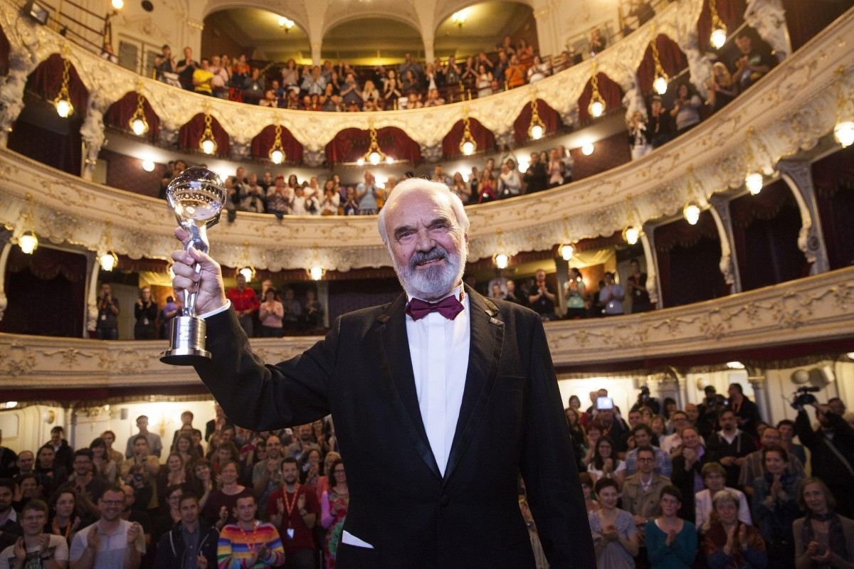

KVIFF TO PRESENT WORLD PREMIERE OF RESTORED INTIMATE LIGHTING
The Karlovy Vary International Film Festival is continuing with a successful tradition from recent years and including the world premiere of another digitally restored jewel of Czech cinematography in its programme, Intimate Lighting by director Ivan Passer. The digital restoration of this film is being done in cooperation with the Czech Film Foundation and the State Cinematography Fund. The technical modification of the film was undertaken by the leading Czech studio UPP and sound studio Soundsquare, which have worked on all of the digitally restored copies of the films up to now.
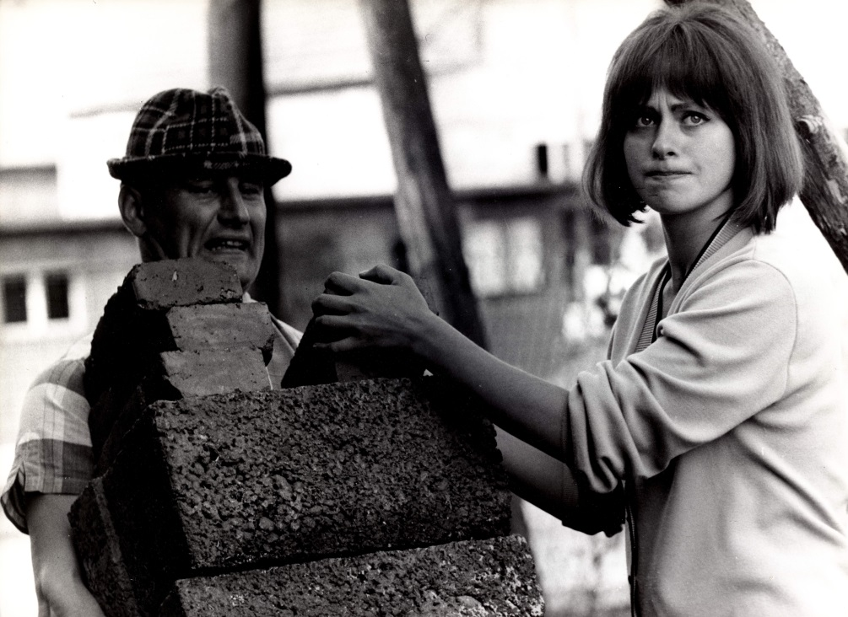
The bittersweet comedy about an encounter between two former classmates and musicians is one of the most striking films of the Czechoslovak New Wave of the 1960s and film historians have ranked it as one of the ten best domestic films of all time. Ivan Passer’s 1965 feature directorial debut is also his only film to be made in Czechoslovakia, the remainder of his filmography having been produced in the USA following his emigration. Intimate Lighting attained enormous international acclaim, despite the management of Barrandov Studios of the time calling it “the most boring film ever shot”.
Ivan Passer is the holder of the 2008 Crystal Globe for Outstanding Artistic Contribution to World Cinema.
The tradition of presenting digitally restored copies of important Czech and Czechoslovak films began in 2011 when the Karlovy Vary IFF had František Vláčil’s Marketa Lazarová restored with the support of the NFA and the Ministry of Culture and held a gala screening. The film was restored under the financial auspices of KVIFF general partner ČEZ. Other titles screened at the KVIFF were then digitalised in cooperation with the Czech Film Foundation and the NFA. Gradually, premiere screenings were held for the restored copies of Miloš Forman’s The Firemen's Ball in 2012, the Moravian epic All My Good Countrymen by Vojtěch Jasný in 2013 and Menzel’s Closely Observed Trains in 2014. At last year’s KVIFF, a new, joint project between the Czech Film Foundation, Czech Television and the Karel Zeman Museum called “Cleaning Up the World of Fantasy” saw the gala presentation of the digitally restored version of Karel Zeman’s Invention for Destruction.
“I am very glad that in spite of all the difficulties and thanks in particular to our new partners we have been able to continue in the successful tradition of premieres of digitally restored films at the KVIFF. We hope the audiences will appreciate being able to see Passer’s wonderful film on the big screen after such a long time, and with the same quality that it had when it first premiered. I would like to thank all those who have made donations until now, and I am sure that thanks to the film festival others still will get involved in this fundraising event, in which ‘the nation gives unto itself’“ says Petr Šikoš, chairman of the board of the Czech Film Foundation.
The gala premiere of the digitally restored copy of Intimate Lighting will take place in the presence of director Ivan Passer on Saturday, July 2 from 2 pm in the Grand Hall of the Thermal Hotel.
The Czech Film Foundation has set up public collections for the digital restoration of the jewels of Czech cinematography. You can donate 30 crowns by sending a text message reading DMS BIJAKY to the number 87 777. For more on digital restoration and the projects of the Czech Film Foundation see www.bijaky.cz.

ACTIVITIES OF CEZ GROUP, THE GENERAL PARTNER, DURING THE 51st KVIFF
CEZ Group is the general partner of the Karlovy Vary International Film Festival for the fifteenth time this year. This time, CEZ Group together with Karlovy Vary IFF will invite all festival visitors as well as Karlovy Vary residents to a concert featuring famous movie melodies, co-organized with the Czech National Symphony Orchestra. The audience will be able to attend it in front of the Thermal Hotel during the Opening ceremony. The traditional music festival Energy Fest will start at Poštovní Dvůr one day later. It will have a cultural as well as a charitable dimension thanks to the Nadace CEZ Foundation’s Move to Help event.
A FEMALE TAKE ON MEXICO
The festival will present the current generation of talented Mexican female directors through nine films from the past five years. It will thus be following on from the programme focusing on women directors from Russia which enjoyed unprecedented success at KVIFF 2009.
The founding of the IMCINE film institute in 1983 was of undeniable importance to the increase of female directors in Mexico. It was this organisation which assisted the careers of the country’s most outstanding writer-directors and paved the way towards new Mexican cinema that soon began making a splash at international festivals. Alongside the legendary names of their more famous male colleagues, the new millennium saw an unprecedented number of women enter the Mexican film stage, the majority born in the early 1980s.
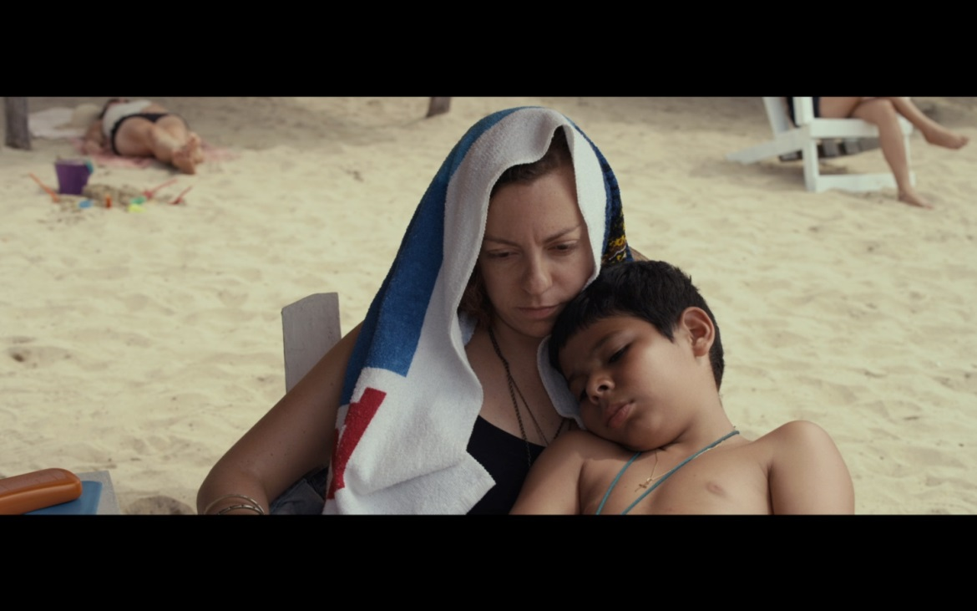
Young female directors, most of them university educated, captured the imagination not only of viewers, but also festival juries and consequently producers as well primarily with the courageous and spontaneous way they introduce into their films their generation’s specifically feminine take on reality, love and sex, and also issues of parenthood, the quest for the meaning of life and for their own identity. Yet they also have their own special way of looking at social problems, and of isolating aspects of reality which their male counterparts might overlook. In Victoria Franco’s first feature Through the Eyes (A los ojos, 2014), which the director made with her brother Michel, the protagonist is a social worker trying her utmost to help the human wrecks languishing amid piles of trash as the victims of alcohol and drugs. The festival will also present Franco´s short film Borde (2014). Elements of social realism will also be found in Claudia Sainte-Luce’s first film The Amazing Cat Fish (Los insólitos peces gato, 2013), whose main character is unexpectedly lifted from her tedious existence as a supermarket cashier when she meets an unusual family who take her into their fold. Humour, if rather unintentional, also underlies The Pleasure Is Mine (El placer es mío, 2015), whose author Elisa Miller is the best known Mexican female director in international circles and the only one to have won a Palme d’Or for her short movie Watching It Rain (Ver llover, 2006). The story of two people living in an unstable relationship and the rejection of the substitute father by the woman’s eight-year-old son is the subject of Semana Santa (2015), whose creator Alejandra Márquez Abella made two documentaries before shooting this feature debut. A romantic encounter fuels the second film by Katina Medina Mora You’ll Know What to Do With Me (Sabrás qué hacer conmigo, 2015), whose protagonists have to deal with health issues and whose treatment betrays the director’s experience in stage direction.
Of the work of the already well-known director Yulene Olaizola, the showcase will include her remarkable elegiac meditation on the futility of being Fogo (2012), which in 2012 was part of the Directors' Fortnight in Cannes. Melancholy tones also characterise Tatiana Huezo’s Tempestad (2016), recently screened at the Berlinale. Here, too, documentary and feature intertwine in a work that is consistent in its authentic portrayal of the lives of social outcasts. In a certain sense, the characters appearing in Betzabé García’s documentary Kings of Nowhere (Los reyes del pueblo que no existe, 2015) are also outsiders, this time set in a partially submerged village in north-western Mexico. The youngest of the Mexican female directors we are presenting was born in 1990. Their collective talent and vital creativity provide a guarantee that we’ll be seeing their new films in future years, both at the Karlovy Vary IFF and at other world festivals.

A TRIBUTE TO OTTO PREMINGER AT THE 51st KVIFF
The festival will commemorate the work of the controversial visionary and the very first independent American filmmaker through eight of his films, including the legendary Laura.
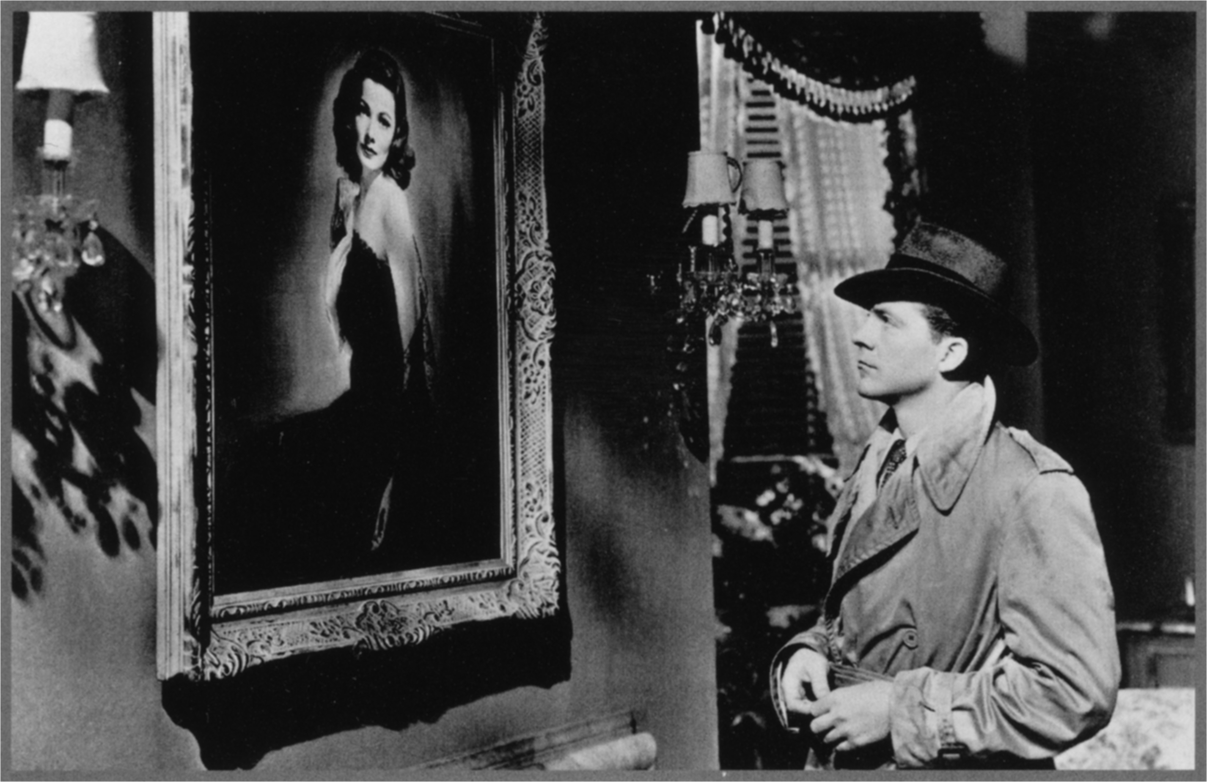
“He could be such a bully on the set and could destroy people, and then he would be a charming, witty companion at dinner who knew the best wines and caviar,” recalled actress Deborah Kerr of one of the most distinctive personalities of the overseas film industry, Otto Preminger (1905 – 1986). “Otto was a terrorist – he’s Arafat, a Nazi, Saddam Hussein – who never knew the difference between lying and not lying,” said author Leon Uris in exasperation over their problematic work together on the film adaptation of his best-selling novel Exodus, while Frank Sinatra, the star of The Man with the Golden Arm (1955), had nothing but words of admiration for Preminger (“Otto was so smart in every possible way”).
The native Austrian who set out across the Atlantic in 1935 broached a number of taboo themes, thereby significantly influencing the development of the American film industry. The first ever independent producer working with autonomy in the Hollywood system, Preminger emerged victorious from a variety of clashes with the censors, and with the gusto of the challenge-inclined he successfully fought against racial, sexual, and other prejudices. He offered powerful, career-launching roles to well-known actors such as Ben Gazzara and Kim Novak, and gave their much admired colleague William Holden a share in the profits as compensation for a salary cut – the first producer to do so. He brought Jean Seberg to the silver screen, and she went on to become the grand muse of the French Nouvelle Vague, as well as New York graphic designer Saul Bass, and by listing Dalton Trumbo’s real name in the credits he de facto rehabilitated the outstanding screenwriter, a victim of McCarthyism long forced to work under a pseudonym after headlining the Hollywood blacklist.
A director, producer, actor and screenwriter, Otto Preminger belonged to a group of European directors, who, in the 1920s headed overseas and in the following decades fundamentally influenced the character of local film production. By adapting the rules of various genres they created crucial works within an evolving industry. While centrepiece of the Karlovy Vary showcase will no doubt be the outstanding film noir Laura (1944), there is also the potential for an audience favourite in Preminger‘s successful adaptation of the theater play The Moon Is Blue (1953), with which he entered the history of film not only as one of the first “indie” directors and producers but also as an unflinching fighter against both hypocrisy and the system of censorship, whose antiquated rigidity he turned upon itself to promote his own “scandalous” work. Also on view in Karlovy Vary this year will be Preminger’s controversial study of drug addiction The Man with a Golden Arm (1955), his adaptation of Françoise Sagan’s bestseller Bonjour Tristesse (1958) starring Jean Seberg, the remarkable courtroom drama Anatomy of a Murder (1959), the epic Exodus (1960) and probably the most acclaimed political drama of the last century Advise & Consent (1962). The programme will close with the extremely informative documentary portrait Anatomy of a Filmmaker (1991), in which the audience is taken through the director’s career by his frequent collaborator, actor Burgess Meredith.

BACK TO FUTURE FRAMES
For the second time now, the Karlovy Vary IFF will be holding the Future Frames: Ten New Filmmakers To Follow programme, which is organised in cooperation with the European Film Promotion. This year too, based on the nominations of EFP member organisations, the festival has selected ten students of film schools from ten European countries whose work hitherto shows great potential. During two days of the festival, the young filmmakers will personally present their films to the general and professional public, and will have the opportunity to meet leading experts from the film industry. For beginning talents, Future Frames opens the door to the world of professional filmmaking and allows them to make important contacts for the preparation of their future projects. “The opening year of Future Frames was one of the most successful and most internationally visible events of last year’s KVIFF,” says festival artistic director Karel Och. “Following a world premiere in Karlovy Vary, rising star of domestic cinema Ondřej Hudeček visited a number of festivals with his baccalaureate film Peacock, including Toronto and Sundance, where the film won the award for best director. Filmacademy Vienna student Patrick Vollrath also achieved great success, with his film Everything Will Be Okay boasting an Oscar nomination and a Student Academy Award.” The Karlovy Vary IFF is one festival that devotes special attention to emerging talents, and the successes of participants from last year’s Future Frames show that this new KVIFF programme is becoming a significant platform for filmmakers at the start of their careers whose names would be good to remember.
Partners of the Future Frames: Ten New Filmmakers To Follow are Sundance Channel and Nespresso.

SPECIAL SCREENINGS OF WINNING FILMS
The 51st Karlovy Vary festival will present a new event - special re-screenings of this year’s winning films to take place on Sunday, 10 July in the Grand Hall of the Thermal hotel. There will be three screenings (at 10 am, 1 pm and 4 pm) of three of the films that were awarded this year, including the best feature film. Tickets for individual screenings can be obtained on Saturday and Sunday (9-10 July) either with accreditation valid for Saturday, 9 July, or by buying them at selected ticket offices. The festival agreed to host this event after discussion with visitors and guests, who welcomed the opportunity to see the winning films. At the same time, we would like to expand the offer of screenings for residents of Karlovy Vary and surrounding areas who have not been able to see the festival films, for example because of their work schedule.

FILM INDUSTRY AT THE 51st KARLOVY VARY IFF
This year the Karlovy Vary IFF wants to continue improving its facilities for film professionals and be a place for them to get connected and meet one another while showing the Czech Republic as a destination suitable for film production and post-production. At the same time the Film Industry Office, in cooperation with its partners, is striving to be a better platform for new filmmakers, established directors and producers from the East European region or film buyers and distributors from all over the world.
The Karlovy Vary IFF in cooperation with Barrandov Studio will open a new Industry meeting place “Film Industry Pool” located above the Thermal swimming pool where Film Industry professionals and filmmakers can meet during the whole festival.
Over the 12 years of its existence, the Works in Progress project has enabled the creation and completion of many new films. The prize for the most promising Works in Progress project from Central and Eastern Europe, the post-Soviet countries, Turkey and Greece will be even more attractive thanks to its new partners. The winning project will receive a post-production package, including video and audio services, as well as finances for the completion of the film in Czech post-production studios which, if compared to previous years, will be far more substantial in 2016. Submissions will be open until May 13.
The Film Industry program 2016 will offer various events including a few new ones:
The festival will also be presenting the first Eurimages Lab Project Award, which will be given to a European project that is on the edge of the conventional approach to film and presents a new form of artistic and visual expression. The eight projects that have been chosen and presented will vie for the award with a financial reward of 50,000 Euros. Submissions will be open until April 30.
Traditionally, documentary projects from Central and Eastern Europe in the production and post-production phases (Docu Talents @KVIFF), as well as Czech and Slovak projects that are still in the development phase but have international co-production potential (Pitch & Feedback @KVIFF), will also be presented in cooperation with our partners.
For the second year in a row, the Karlovy Vary Festival will be hosting the annual gathering of the network of independent European Distributors, Europa Distribution, whose workshops on the theme of “Film Education and Literacy” will also be open to film professionals. At the same time we hope to be devoting more time to the issue of the digital market in the context of new strategies from the USA.
Educational platforms at the festival enable filmmakers to meet experts in their fields. The partnership with Torino Film Lab opens up an opportunity to look at the comedy genre – how to approach it properly so that it works on an international level. About 60 TFL graduates and tutors will be meeting in Karlovy Vary to examine the genre’s opportunities and pitfalls.
This year for the first time the MIDPOINT screenwriting platform, in cooperation with experts from the Sundance Institute, will be presenting an intensive program as part of the Karlovy Vary Festival.

