Organizer of the 52nd Karlovy Vary IFF 2017: Film Servis Festival Karlovy Vary, a.s.

Organizers of the 52nd Karlovy Vary IFF thank to all partners which help to organize the festival.

52nd Karlovy Vary IFF is supported by:
Ministry of Culture Czech Republic

General partner: CEZ Group

Main partners: Vodafone Czech Republic a.s.

innogy
Pivovary Lobkowicz Group
City of Karlovy Vary

Partners: UniCredit Bank Czech Republic and Slovakia, a.s.
UNIPETROL, a.s.
KKCG investment group
Karlovy Vary Region
Official car: BMW
Official coffee: Nespresso
In cooperation with: CzechTourism, Ministry of Regional Development
Partner of the People Next Door section: Sirius Foundation
Official beverage: Karlovarská Korunní
Official champagne: Moët & Chandon
Official drink: Finlandia Vodka
Official make-up artist: Douglas
International shipping partner: DHL Express (Czech Republic), s.r.o.

Main media partners: Czech Television
Czech Radio Radiožurnál
PRÁVO
Novinky.cz
REFLEX
Media partners: JCDecaux Group
ELLE Magazine
magazine TV Star
Radio 1
Festival awards supplier: MOSER, a.s.
Supplier: JT International spol. s r.o.
Hardware supplier: Fujitsu
Software solutions: Microsoft
Consumer electronics supplier: LG Electronics
Partner of the festival Instagram: PROFIMED
Main hotel partners: SPA HOTEL THERMAL
Grandhotel Pupp
Augustine, a Luxury Collection Hotel, Prague
Partner of the No Barriers Project: innogy Energie
Partner of the Industry Pool: Barrandov Studio
Wine supplier: Víno Marcinčák
GPS technology supplier: ECS Invention spol. s r.o.
Official bike: Specialized

KARLOVY VARY INTERNATIONAL FILM FESTIVAL WILL HONOR GLOBALLY RECOGNIZED MUSIC COMPOSER JAMES NEWTON HOWARD
Music composer James Newton Howard, the author of music to legendary movies such as Pretty Woman, The Sixth Sense, Batman Begins and all four parts of The Hunger Games will be a guest at the 52nd Karlovy Vary International Film Festival, where he will receive the Crystal Globe for Outstanding Artistic Contribution to World Cinema.
The public will be able to meet the respected composer during the Opening Ceremony concert in front of the Hotel Thermal. James will personally conduct a world premiere of the music from his latest movie, Fantastic Beasts and Where to Find Them, which will be performed by the Czech National Symphony Orchestra.

Photographer Credit: Mark Hanauer

He is currently preparing for his first live concert tour. The 3 Decades of Music for Hollywood concert production will be a celebration of career highlights with music, spoken word and video.
Mr. Howard will conduct a symphony orchestra and choir comprising over 100 performers on stage through suites of recent as well as classic film hits. The composer will tell stories from his rich and wide-ranging experience, working on some of the most honored and successful movies ever made, with on-screen commentary from several of his long time Hollywood collaborators, along with clips and montages of stills from films. The tour will visit 20 of the biggest European cities in November 2017, with the premiere being held at the Royal Albert Hall on November 3rd 2017. Among other cities, the live concerts can be seen later in November in Prague, Krakow, Warsaw and Budapest

One of the most versatile and respected composers currently working in film, James Newton Howard’s career spans over thirty years. He has composed music for over 120 films, including the Academy Award-nominated scores for Defiance, Michael Clayton, The Village, The Fugitive, The Prince of Tides, and My Best Friend’s Wedding, and Academy Award-nominated songs for Junior and One Fine Day. Howard also received Golden Globe nominations for his massive orchestral score for Peter Jackson’s blockbuster remake of King Kong, his provocative symphonic score for Defiance, and his songs from Junior and One Fine Day.
Howard won the 2009 Grammy Award for his co-score with Hans Zimmer for The Dark Knight, and received Grammy Award nominations for music from Blood Diamond and his song from One Fine Day.
In addition, he won an Emmy for the theme to the Andre Braugher series Gideon’s Crossing, and received two additional Emmy nominations for the themes to the long-running Warner Bros. series ER and the Ving Rhames series Men. In 2008, World Soundtrack Award named him Film Composer of the Year for his work on the films Charlie Wilson’s War, Michael Clayton and I Am Legend.
His success reflects the experiences of a rich musical past. Inspired by his grandmother, a classical violinist, he began his studies on the piano at age four. After studying at the Music Academy of the West in Santa Barbara, and at the USC School of Music as a piano performance major, he completed his formal education with orchestration study under legendary arranger Marty Paich.
Though his training was classical, he maintained an interest in rock and pop music, and it was his early work in the pop arena that allowed him to hone his talents as a musician, arranger, songwriter and producer. He racked up a string of collaborations in the studio and on the road with some of pop’s biggest names, including Elton John; Crosby, Stills & Nash; Barbra Streisand; Earth, Wind and Fire; Bob Seger; Rod Stewart; Toto; Glenn Frey; Diana Ross; Carly Simon; Olivia Newton-John; Randy Newman; Rickie Lee Jones; and Chaka Khan.
In 1985, he was offered his first film, Head Office, and he quickly knew he had found his calling. Since then, he has scored films such as all four installments of The Hunger Games, Concussion, The Huntsman: Winter’s War, Maleficent, Nightcrawler, Snow White and the Huntsman, The Bourne Legacy, Salt, The Last Airbender, Water For Elephants, Gnomeo & Juliet, Batman Begins, Collateral, Snow Falling on Cedars, Outbreak, The Village, Hidalgo, Peter Pan, Wyatt Earp, Lady in the Water, The Sixth Sense, Unbreakable, Freedomland, Treasure Planet, Signs, Falling Down, Primal Fear, Glengarry Glen Ross, Waterworld, The Devil’s Advocate, Dave, and Pretty Woman among many others. In 2016 he composed the music for the prequel to Harry Potter, Fantastic Beasts and Where to Find Them, which was released in November.
In 2017 he is working on the scores for Disney’s The Nutcracker and the Four Realms, Inner City with Denzel Washington and Red Sparrow with Jennifer Lawrence.
In addition to his contributions to film and television music, Howard has composed two concert pieces for the Pacific Symphony. I Would Plant a Tree debuted in February 2009, and his Concerto for Violin and Orchestra premiered in March 2015, featuring renowned violinist James Ehnes.
Howard has been honored with ASCAP’s prestigious Henry Mancini Award for Lifetime Achievement, as well as the 2016 BMI Lifetime Achievement Award.

KARLOVY VARY FESTIVAL TO PRESENT AWARDS TO DIRECTOR KEN LOACH AND SCREENWRITER PAUL LAVERTY
At the 52nd Karlovy Vary International Film Festival, the Crystal Globe for Outstanding Artistic Contribution to World Cinema will be presented to two individuals who together have influenced the history of British cinema. Director Ken Loach and his long-time screenwriter Paul Laverty have worked together on twelve feature films and two shorts, in the process becoming pioneers of British social realist film with a humanitarian message.
The films of Ken Loach and Paul Laverty are regular winners of awards at renowned international festivals (Cannes, Venice), and Loach in particular has close ties to the festival in Karlovy Vary as well.
At the 16th Karlovy Vary IFF in 1968 Carol White has received Best Female Actress Award for her performance in Loach’s film Poor Cow. The film has also received a Special Jury Prize. In 1970, Loach personally accepted an award at the 17th annual KVIFF for his ground-breaking film Kes, a drama that the British Film Institute has included among the ten best British films of the 20th century. He was also a guest of our festival during one of its first post-revolutionary years, in 1992, and the festival regularly includes the films of Loach and Laverty on its programme.
Ken Loach
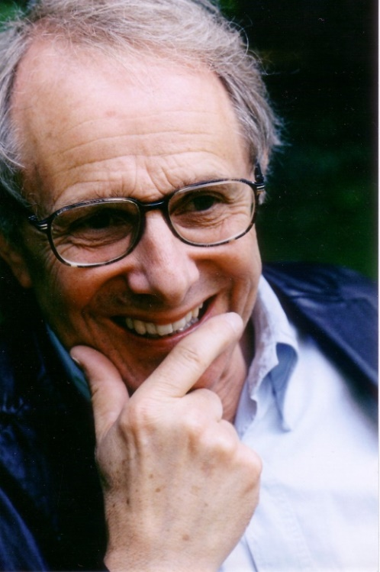
Born in Nuneaton, Loach studied law at St. Peter’s College, Oxford. After a brief period working in theatre, in the early 1960s he began working as a television director for the BBC. His long directing career began with the TV movie Cathy Come Home and the drama Kes, which won him an award in Karlovy Vary. After his breakthrough film Riff-Raff, which won the 1991 European Film Award for Best Film, he created numerous outstanding titles – Land and Freedom (1995), Sweet Sixteen (2002), The Wind That Shakes The Barley (2006, which earned him a Palm d’Or at Cannes), Looking for Eric (2009), The Angels’ Share (2012) and most recently I, Daniel Blake (2016), another winner of the Palm d’Or for best film at the Cannes Film Festival.
Paul Laverty
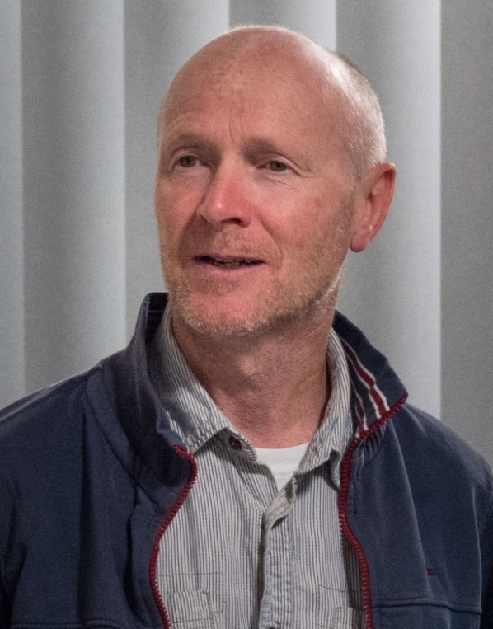
Paul Laverty was born to an Irish mother and a Scottish father in Calcutta, India. After earning a degree in philosophy from the Pontifical Gregorian University in Rome, he went on to graduate from Strathclyde Law School and subsequently worked as an attorney in Glasgow. In the mid-1980s, Paul spent three years living in Central America, where he worked for a human rights organization in Nicaragua.
Paul Laverty has written the script for twelve feature and two short films directed by Ken Loach. My Name is Joe earned Peter Mullan a Best Actor award at the 1998 Cannes Film Festival. Other awards at Cannes include: Best Screenplay for Paul Laverty (Sweet Sixteen, 2002), a Palm d’Or for The Wind That Shakes the Barley (2006), and another Palm d’Or for I, Daniel Blake (2016). Paul Laverty also wrote the screenplays for director Icíar Bollaín’s Even the Rain (Tambien la lluvia) and The Olive Tree (El Olivo).

KVIFF TO SCREEN THE WORLD PREMIERE OF THE RESTORED ACADEMY AWARD-WINNING FILM THE SHOP ON MAIN STREET

The 52nd Karlovy Vary International Film Festival will continue a successful tradition with the world premiere screening of the digitally-restored, Oscar-honored movie The Shop on Main Street from creative pair Ján Kadár and Elmar Klos.

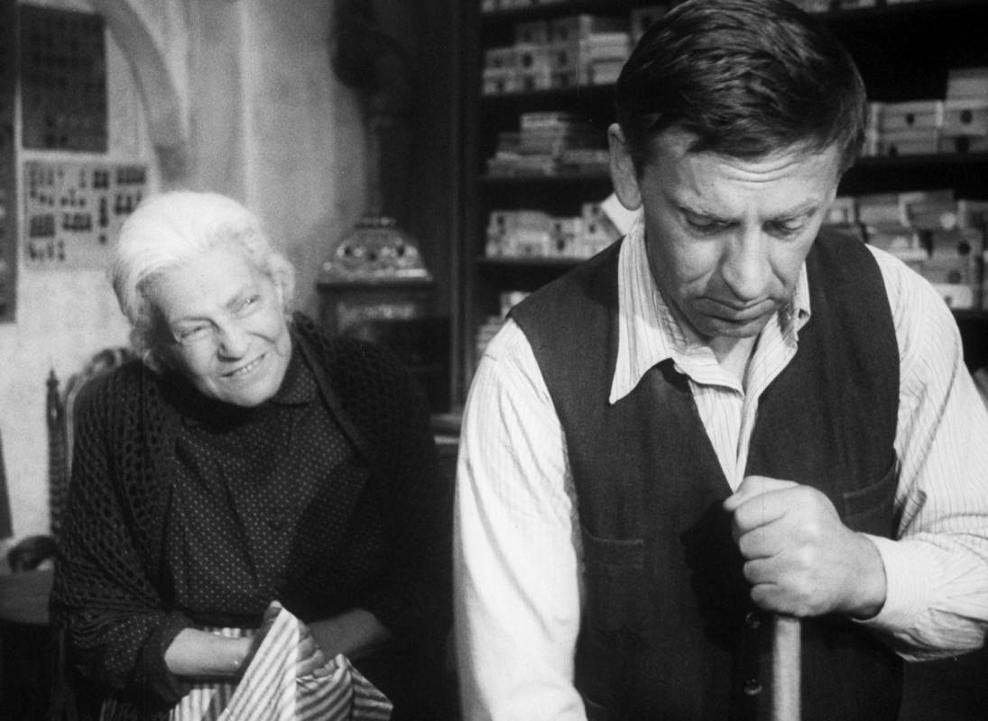

The digitalized print of the film came about in cooperation with the Czech Film Foundation and the State Film Fund. Main Street represents the fifth movie to be digitally restored through the initiative and financing of the Czech Film Foundation; the other titles are The Firemen’s Ball, All My Good Countrymen, Closely Watched Trains, and last year’s Intimate Lighting.

The Shop on Main Street was made in the most prolific and successful period of Czech cinema, known as the New Wave. The filmmakers were, however, an already philosophically and cinematically seasoned directing duo for whom Main Street represented their seventh and penultimate project. For three years they worked on the script, based on a story by Ladislav Grosman, while concurrently making Death Is Called Engelchen (1963) and Accused (1964), which form a loose trilogy with 1965’s Main Street. The plot unfolds in a small town in eastern Slovakia during World War II when a local bigwig in the Slovak People’s Party arranges an Aryanization order for the shop of a Jewish widow named Mrs. Lautmannová. Good-natured Tono Brtko protects the old woman from reality by opting not to acquaint her with the actual political state of affairs, but, at the same time, he is unable to openly attempt to save her. Kadár and Klos created a powerful, timeless story: an evaluation of the courage within us and the need to face down evil in any form. “The foundation of all violence is always made up of good, harmless people who passively accept it,” said Ján Kadár in characterizing the story’s central thrust, to which Elmar Klos added: “It’s highly reductive to depict violence solely as the devil. It can as well be convivial, caring, neighborly – and all the while evil nonetheless.”

The Shop on Main Street took the Academy Award for Best Foreign Language Film in 1966. Its success opened up other possibilities but only for a short time. Ján Kadár emigrated after 1968, and Elmar Klos became the victim of Normalization purges in the former Czechoslovakia. Elmar Klos died in 1993 at the age of 83, surviving his friend and creative partner by 14 years.

The gala premiere of the digitally-restored print of The Shop on Main Street will take place on July 1, 2017 in the Grand Hall, Hotel Thermal.

In conjunction with the digital restoration of The Shop on Main Street, the Czech Film Foundation has launched the fund-raising campaign #vydotitulku. As with the previously restored films Intimate Lighting and The Fabulous Baron Munchausen, donors may have their names permanently attached to the digitally-restored version of this legendary, Oscar-winning movie.

In order for a donor’s name or logo to appear in the film’s closing credits, just send a minimum contribution of 10,000 Czech crowns for the digital restoration of The Shop on Main Street by the end of May 2017 to transparent account 107-5653070287/0100

You may also contribute via text message for 30 Czech crowns: text the phrase DMS BIJAKY 30 to telephone number 87 777. Find out more about this digital restoration and other Czech Film Foundation projects at www.bijaky.cz.

KARLOVY VARY IFF CELEBRATES THE WORK OF JAPANESE MASTER KENJI MIZOGUCHI

One of the most highly respected filmmakers in the history of cinema will be presented at the 52nd KVIFF via a collection of ten fundamental pictures from his extensive filmography as selected by renowned British writer, curator and film critic Tony Rayns.

“At a time when film buffs are often forced to watch classic movies on screens that measure diagonally about the length of your forearm, KVIFF will provide big-screen viewing of mainly 35mm prints for another chapter in our series devoted to filmmakers who had an immense influence on the development of film culture,” said festival artistic director Karel Och.

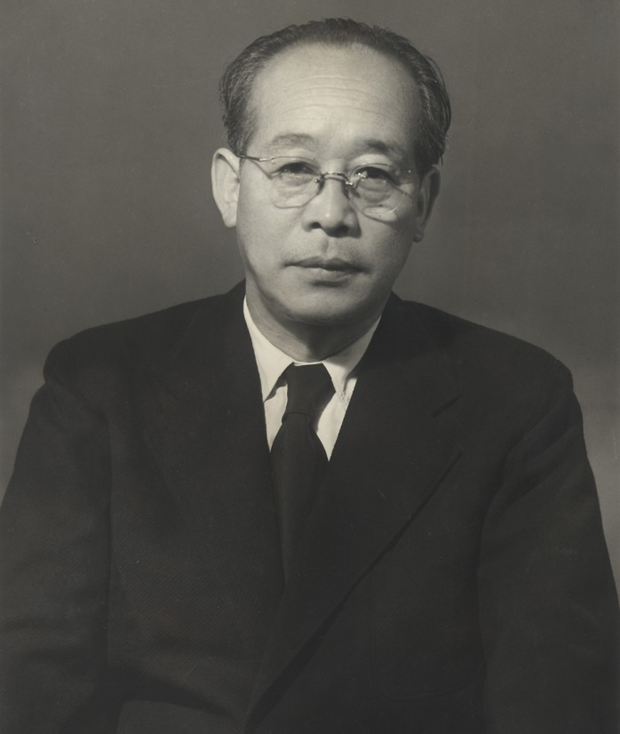
Undoubtedly, the dispute over which of the three essential Japanese directors is the most important has been an indivisible element of the lighter side of film history for decades. The often cited young French critics associated with Cahiers du cinéma magazine gave precedence to Kenji Mizoguchi (1898-1956) over Akira Kurosawa and Yasujirō Ozu. Their paeans to the rich work of this pioneer of modern realism in Japanese film, which best corresponded to their own proselytized auteur theory, dates to the beginning of the 1950s. At that time, Western Europe and North America discovered Japanese moviemaking not only through Kurosawa’s Rashomon (1950) but also by encountering Mizoguchi’s three most famous pictures from the end of his career: The Life of Oharu (1952), Ugetsu (1953), and Sansho the Bailiff (1954).

The Karlovy Vary selection of Mizoguchi movies, and the accompanying documentary portrait Kenji Mizoguchi: The Life of a Film Director (1975) shot by Kaneto Shindô, acquaints audiences with the development of Mizoguchi’s style, which characteristically includes long shots, contemplative camerawork of captivating elegance, and highly specific lighting. Although he plagued actors with his perfectionism, he also provided them a very comfortable environment for establishing an emotional bond with the viewer.

At the center of almost all Mizoguchi films stands a woman, often suffering alongside or abused by weakling men despite her remarkable inner strength to face a tragic fate. The theme of a woman sacrificing herself received exceptionally complex treatment from the maker of subdued melodramas in his prewar creative peak The Tale of the Late Chrysanthemums (1939).

Many renowned filmmakers cite the influence that Mizoguchi’s work had on their perception of film and their creative formation. The words of a few: “He is capable of going beyond the limitations of coherent logic, and conveying the deep complexity and truth of the impalpable connections and hidden phenomena of life“(Andrei Tarkovsky). “He can’t be praised enough, really” (Orson Welles). “On equal terms with Eisenstein, Griffith, and Renoir” (Jean-Luc Godard). “He’s the John Ford of Japanese film” (Viktor Erice).

More information may be found in programme section at www.kviff.com .

KARLOVY VARY IFF WILL PAY TRIBUTE TO JIŘÍ BRDEČKA

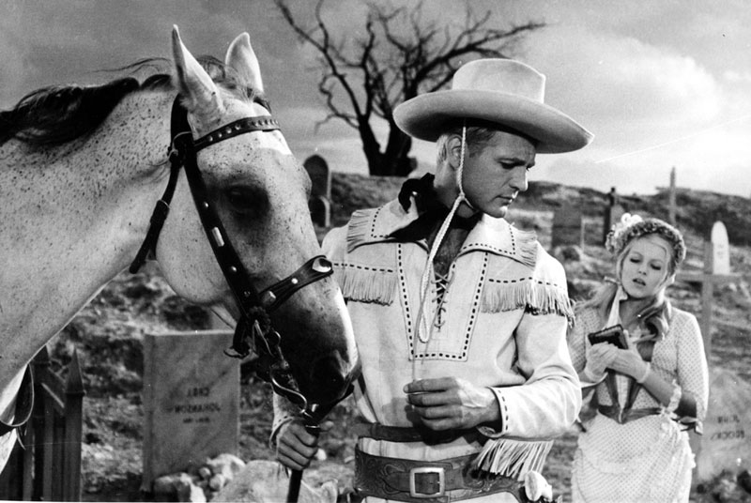
The 52nd Karlovy Vary International Film Festival has prepared to pay tribute to the legend of Czech cinematography Jiří Brdečka on the occasion of the 100th anniversary of his birthday. The festival will present the well-known film Lemonade Joe and the cross-section of the Brdečka’s short films.

It would certainly not be an exaggeration to state that, from the middle of the last century onwards, everyone in this country with an interest in culture would have come across the name Jiří Brdečka. Biographies and articles about him begin with an impressive list of the professions he mastered – journalism, writing, scripting, art and design, illustration and film direction; each would ostensibly have required not only unflagging diligence but, above all, talent. Such a gift had very specific traits and one couldn’t do it justice in only a few words. Brdečka was a poeta doctus, a “learned poet” educated in numerous cultural spheres. When he wrote short stories and screenplays, he found inspiration in a variety of literary works and genres, crafting paraphrases and variations with a refined sense of language. And when he decided to make an animated film – in the majority of cases providing the story and directing the piece himself – he knew exactly which artistic expression would best suit the given subject matter. He had a particular fondness for the type of dramas depicted in kitsch art – he revelled in their tawdriness and yet he was able to draw out their innate emotional purity, hence the curious blend of derision and nostalgia that was typical for his narrative style.

It was extremely auspicious that film played a major role in Brdečka’s career from the outset; his artistry thus found its way into the public domain, and viewers spontaneously absorbed his lessons in word culture, elegant humour, resourceful storytelling, and in a subtle irony filled with intellectual references and hidden messages. It was characteristic of him to attract such luminaries as Jiří Trnka and Jan Werich, directors Martin Frič, Jiří Weiss, Oldřich Lipský, Bořivoj Zeman, Karel Zeman, and also Vojtěch Jasný and Václav Vorlíček, whose works were based on his screenplays or involved his collaboration on the script and are now part of the Czech film industry’s gold collection. Movie enthusiasts are familiar with Trnka’s feature-length puppet animations Old Czech Legends (1952) and A Midsummer Night’s Dream (1959), Frič’s historical comedy The Emperor’s Baker – The Baker’s Emperor (1951), the brilliantly inspired genre parodies Lemonade Joe (1964), Adele’s Dinner (1977) and The Mysterious Castle in the Carpathians (1983), all directed by Oldřich Lipský, and his fairy tales for children (Once Upon a Time, There Was a King; Stick, Start Beating!; The Prince and the Evening Star) and for adults (The Outrageous Baron Munchausen; That Cat…). Audiences are less aware, however, that Brdečka also worked on the screenplays for various film dramas, among them Lost People (1956, dir. Miloš Makovec) and The Wolf Trap (1957, dir. Jiří Weiss), and that one of his short stories provided the basis for Věra Chytilová’s 1983 film The Very Late Afternoon of a Faun. Moreover, the international critical acclaim afforded to the Czech animation school during the 1950s and 1960s was in great part due to him: Not only did he have a flair for bringing in highly original artists and illustrators, but he also transformed an art form intended chiefly for children into a tool for metaphorical reflection on weighty themes. It seems incredible that 2017 marks a full century since this multitalented Maestro was born.

THE KARLOVY VARY IFF TO AWARD DIRECTOR VÁCLAV VORLÍČEK
The KVIFF President’s Award for Artistic Contribution to Czech film will be conferred upon screenwriter and director Václav Vorlíček at the 52nd Karlovy Vary IFF.
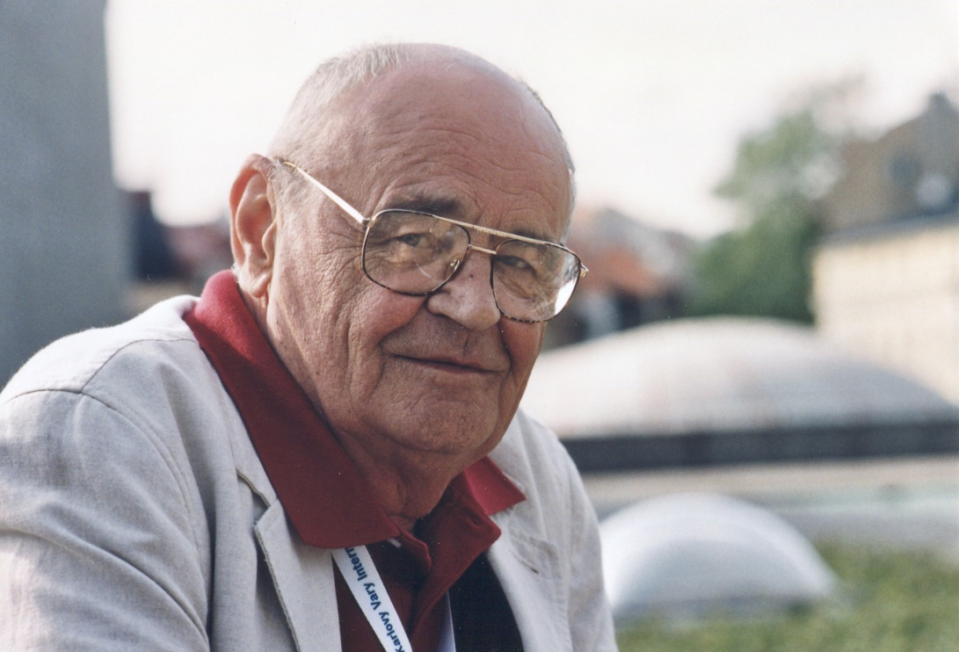
The renowned director, who will celebrate his 87th birthday shortly before the start of the festival, first graduated from Prague’s Film Academy (FAMU) then worked as an assistant director at Barrandov Film Studios before fully launching an independent career in the 1960s. His first movies were geared toward child audiences, and, although his work soon displayed genre diversity, he returned to entertaining kids throughout his career. Photographer Credit: Miloš Fikejz
Václav Vorlíček teamed up with writer and director Miloš Macourek, his longtime colleague and friend, to form an original creative duo responsible for a distinctive chapter in the development of Czech film. Their poetic vision, in which real life comes up against elements of fantasy, remains unique to this day. Vorlíček and Macourek became masters of absurdity, of the genre paraphrase, of combining characters in the artificial world with those of reality. The top exemplars of their work along these lines are the “comic book” comedy Who Wants to Kill Jessie? (1966), the sci-fi crazy comedy You Are a Widow, Sir! (1970), the fairytale comedy The Girl on the Broomstick (1971), a comedy which employs fairytale motifs in contemporary Prague entitled How to Drown Dr. Mracek, the Lawyer

(1974), the TV series “Arabela” (1979-80) and “Flying Čestmír” (1983), and Rumburak (1984).
As mentioned above, the rich genre variety of Vorlíček’s work was rounded out with fairy tales in the 1970s and 1980s. Above all, Three Wishes for Cinderella (1973), awarded at a number of festivals, has become a Christmas holiday classic on Czech television, and despite the more than four decades since its release, each year it airs on TV to high ratings. Václav Vorlíček pursued another fairytale story in How to Wake up Princesses (1977), a loose adaptation of Sleeping Beauty, while the third in his series of fairytale modernizations became The Prince and the Evening Star (1978).
The fairytale genre is also typical of Vorlíček’s work of the past 20 years – The Firebird (1997) and Queen of the Lake (1998). His latest film to date was, Little Witch on a Broomstick (2011), a loose continuation of the successful Girl on the Broomstick.

NEW FESTIVAL TRAILER TO FEATURE ACTOR JOSEF SOMR
The new trailer for the Karlovy Vary International Film Festival, which will be presented at the opening of the 52nd annual festival, features Czech acting legend Josef Somr. This film and theatre actor was the winner of the KVIFF President’s Award in 2012. The trailer will once again be shot by the long-time director of KVIFF’s festival trailers, director Ivan Zachariáš.
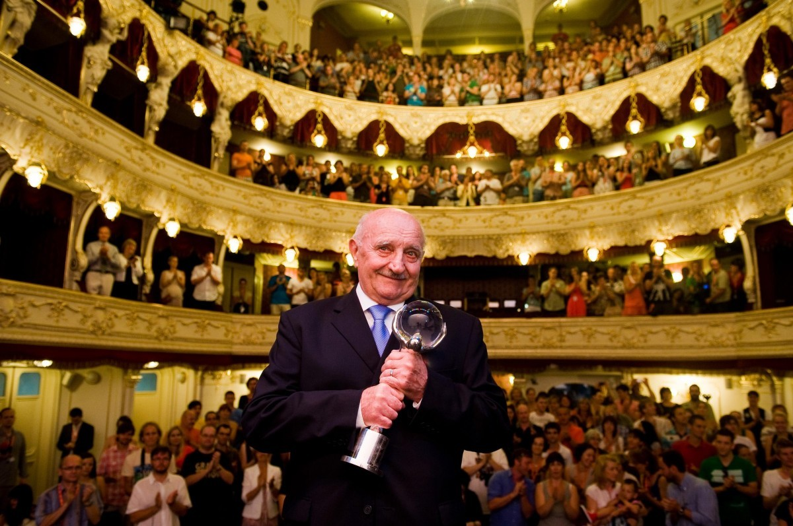

OPENING CONCERT AGAIN IN FRONT OF THE HOTEL THERMAL
The 52nd Karlovy Vary International Festival continues the tradition of holding an opening concert for the general public. For the third year, we have decided to celebrate the start of the festival with the festival’s visitors and with the residents of our host city. After the popular performance by the Czech band Lucie at last year’s concert of film melodies, this year’s opening concert on 30 July 2017 will again feature a selection of film music.
At this year’s concert, the Czech National Symphony Orchestra, under the direction of American conductor and composer Carl Davis, will present primarily music from famous James Bond movies. Carl Davis has composed the original score for numerous film and television projects, including The French Lieutenant’s Woman and Widows’ Peak, and collaborated with Paul McCartney on the famous Liverpool Oratorio.
Also appearing as a special guest is composer and this year’s recipient of the Crystal Globe for Outstanding Artistic Contribution to World Cinema, James Newton Howard, who will conduct the world premiere performance of selected music from the recently completed sequel to Fantastic Beasts and Where to Find Them.
The Karlovy Vary IFF is holding the official opening concert in cooperation with the festival’s general partner, ČEZ Group. The partner of the opening concert is Unipetrol.
The concert begins at 10pm on June 30 on the stage in front of the Hotel Thermal. Admission is free.

ACTIVITIES OF THE GENERAL PARTNER OF THE KARLOVY VARY INTERNATIONAL FILM FESTIVAL, THE ČEZ GROUP, DURING THE 52ND FESTIVAL
On Saturday 1 July, the day following the official opening concert co-hosted by the ČEZ Group, the festival will present its traditional ČEZ ENERGY FEST at the Poštovní dvůr. As in the past, admission is free for visitors with festival passes.
Part of the ČEZ Energy Fest will be the Orange Bike from the ČEZ Foundation, making the fest a cultural as well as a charitable event.

SPECIAL SCREENING OF WINNING FILMS, SUNDAY JULY 9
Last year was the first time that the Karlovy Vary International Film Festival held special Sunday screenings of the winning films from the festival’s 51st year. The festival came up with this new programme addition after talking with visitors and guests, who welcomed the possibility of seeing the winning films. The event was also positively received by audiences from Karlovy Vary and the nearby surroundings who could not make it to festival screenings because of work obligations. In view of this great interest, we have decided to continue with the project.
Special screenings of winning films from the 52nd KVIFF will be held on Sunday July 9 in the Grand Hall of the Hotel Thermal. The three screenings (10am, 1pm, and 4pm) will present three award-winning films from this year’s festival, including the winner of the Crystal Globe. Tickets to the screenings will be available on Saturday and Sunday (July 8 and 9), either on the basis of accreditation valid on Saturday July 8 or by purchasing tickets at selected ticket offices.

PEOPLE NEXT DOOR SECOND TIME AT KVIFF
For the second year in a row, the Karlovy Vary International Film Festival presents a section called The People Next Door. The section’s partner is the Sirius Foundation, the official non-profit partner of the 52nd annual KVIFF. The People Next Door – a section of films about people with handicaps – was launched last year to great audience response.
This year, the section will focus specifically on films about people with various vision impairments.

FILM INDUSTRY AT THE 52nd KARLOVY VARY IFF
This year again, the Festival will continue to provide an adequate base for over a thousand of accredited film professionals from the Czech Republic and abroad. The Film Industry Pool pavilion will continue to be at their disposal for lectures, discussion talks and presentations of various topics ranging from film development, film production to distribution. Traditionally, Works in Progress film projects in post-production phase from the region of Central and Eastern Europe, post-soviet states, Turkey and Greece will be introduced. The most promising project will receive a post-production award package in a total value of 100.000 EUR enabling thus its completion. For the second time, a presentation of film projects Eurimages Lab Project will take place. It focuses on new or unusual forms of cinematographic expression and non-standard production or dramaturgical approaches. The awarded project will receive 50,000 EUR. A Docu Talents @KVIFF presentation of documentary films in-the-making will provide buyers with an overview of what is being prepared in the region of Central and Eastern Europe.
Promising Czech and Slovak projects in development phase will be pitched to potential buyers and co-producers at the traditional Pitch & Feedback presentation. Selected screenwriters from the region will have a chance to participate in the MIDPOINT Intensive @KVIFF workshop, improving their scripts under the supervision of top tutors from the Sundance Institute. TorinoFilmLab which brings to life a large number of festival films will organize an annual meeting of five dozens of its alumni in Karlovy Vary. For the first time ever, winners of the local competition Nespresso Talents will introduce their short films made for the vertical 9:16 screen. Support for this competition has been jointly provided by Karlovy Vary International Film Festival and Prague Short Film Festival.

