KVIFF Press Release Tuesday, 4 July 2017
Karlovy Vary

The winners of the Works in Progress Award and Eurimages Lab Project Award @KVIFF 2017

Jury
- Iole Maria Giannattasio, Directorate General for Cinema of the Italian Ministry of Cultural Heritage, Activities and Tourism, MiBACT
- Cedomir Kolar, producer, A.S.A.P. Films
- Susana Santos Rodrigues, film programmer, distributor producer and co-founder of VAIVEM

Works in Progress Award @KVIFF
At the 14th edition of Works in Progress @KVIFF, eight selected projects (plus one out of competition) were presented from a total of 77 submissions from Central and Eastern Europe, the Balkans, Turkey, Greece and post-Soviet territories. The 2017 award, with a total value of EUR 100,000, includes post-production services at UPP and Soundsquare and a EUR 10,000 cash award from Barrandov Studio.

Censor (Cenzorka), directed and produced by Peter Kerekes and written by Ivan Ostrochovský, was awarded for its original and vivid human portrait of a lonely woman.

Eurimages Lab Project Award @KVIFF
The Karlovy Vary IFF is one of four international festivals to present this award. The final eight projects were selected from 45 submitted projects from Eurimages countries that are currently in production or post-production, are being made outside the traditional filmmaking framework, and involve international co-operation. The best project receives an award of EUR 50,000.

The Stand-In (La Controfigura), directed and written by Rä di Martino and produced by Marco Alessi, was awarded for its ironic visual experimental approach to innovative narrative and for being an intersection of art and film.

More information about projects:

CENSOR (Cenzorka)
80 min, Slovakia

Directed by: Peter Kerekes
Scriptwriter: Ivan Ostrochovsky, Peter Kerekes
Camera: Martin Kollár
Cast: Irina Alexandrovna, Jura Car, Ljubov Vassilina
Language: Ukrainian, Russian
Website: www.kerekesfilm.com
Release date: 07/2018
What’s missing: third co-producer, international sales

Film synopsis
Irina Alexandrovna works as a censor in an Odessa prison. The inspection of letters is required by law in order to prevent the continuation of criminal activity. But the real criminals use smartphones, and old-fashioned letters are only used for declarations of love. So Irina spends eight hours a day in her office reading love letters. Through her, we follow various love affairs that only she can observe. Although she sees how women being used, and how the relationships end in disaster for them, she cannot take any action. Our heroine is a single woman and after twelve years of reading love letters full of the lies men tell, she is not capable of any relationship. If a guy on a date says “You are special,” she feels sick. But of course even she dreams of love.

Director’s biography
Peter Kerekes, born 1973 in Košice, finished his film studies at the Film and TV Faculty of the Academy of Performing Arts in Bratislava in 1998 with his diploma film Morytats and Legends of Ladomirova.

Director’s filmography
- Velvet Terrorists (2013) – audience award (Tagesspiegel Award) at the 2014 Berlinale, FEDEORA award in Karlovy Vary in 2013
- Cooking History (2009) – jury award at 2009HotDocs, best film at the 2009 Chicago Documentary Film Festival, nominated for best documentary at the European Film Awards

Producer’s biography
Peter Kerekes, born 1973 in Košice, finished his film studies at film and TV faculty of Academy of Performing Arts in Bratislava in 1998 with his diploma film Morytats and Legends of Ladomirova.

Producer’s filmography
- Velvet Terrorists (2013) – audience award (Tagesspiegel Award) at the 2014 Berlinale, FEDEORA award in Karlovy Vary in 2013
- Cooking History (2009) – jury award at 2009 HotDocs, best film at the 2009 Chicago Documentary Film Festival, nominated for best documentary at the European Film Awards

Producer’s statement
The film is based on real situations and real characters and involved in-depth research conducted by the filmmakers at numerous prisons. The script was distilled from these materials, stories and characters. The plot follows the tragicomic micro-love stories between jailed men and women on the outside, as seen through the main protagonist. The film was shot with actors and non-actors (prisoners and ex-prisoners), mostly in a real setting, a real prison. We finished ten shooting days in January 2016 and 14 shooting days in August 2016 and are preparing further shooting this September. The film’s expected premiere is in 2018.

Contacts
Peter Kerekes s.r.o.
kerekes@nextra.sk
www.kerekesfilm.com

Hypermarket Film s.r.o.
filip@remunda.com
www.hypermarketfilm.cz

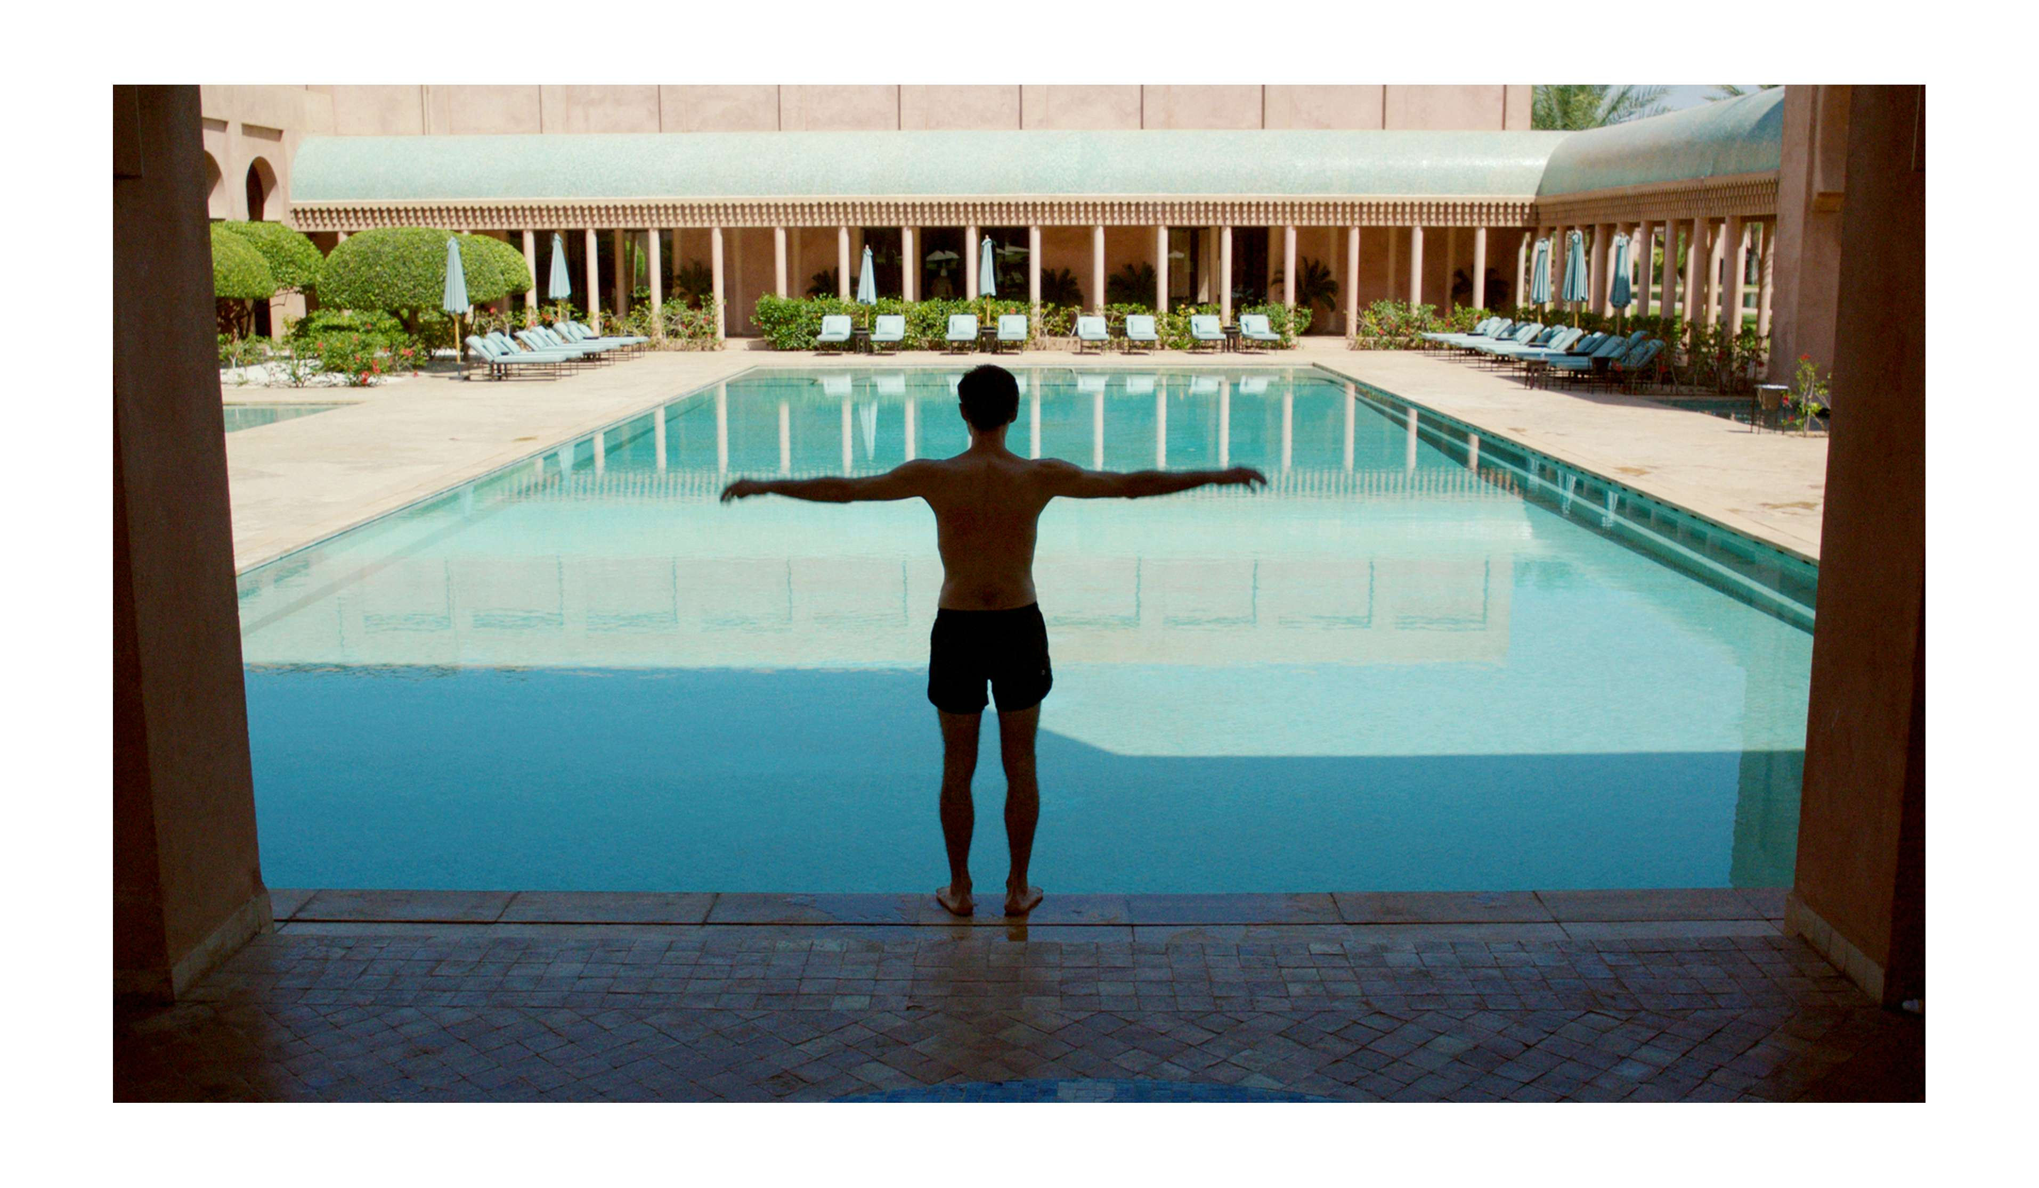

The Stand-In (La Controfigura)
70min, Italy, France, Morocco

Directed by: Rä di Martino
Scriptwriter: Rä di Martino
Producer: Marco Alessi
Camera: Gianclaudio Giacomini, Giulio Squillacciotti, Hasnae el Ouarga
Music: Albergo intergalattico spaziale
Cast: Valeria Gollino, Filippo Timi, Corrado Sassi, Younes Bouad, Nadia Kounda, Nisrine Adam
Language: Italian, French, English, Arabic
Website: www.dugong.it/la -controfigura/
Release date: spring 2018
What’s missing: Final Editing, Sound Postproduction, Colour Grading

Film synopsis
A small crew has been travelling around Marrakech and its surroundings looking for swimming pool locations for the remake of an American movie in which a man crosses the county, pool by pool, to reach his home. In The Stand-In, the filmmakers rehearse the shots to find the path through the city and the pools that the main actor will run and swim through. AS we watch his struggles to become more than just a stand-in figure, the real actors and film crew burst onto the scene on a set where nobody seems to be in the right place. A film in search of itself, looking for where the real film is.

Director’s biography
Rä di Martino (Rome 1975) studied at the Chelsea College of Arts and the Slade School of Fine Art in London before living in New York between 2005 and 2010. She has exhibited nationally and internationally at institutions such as the Tate Modern, London; MoMA PS1, New York; Palazzo Grassi, Venice; GAM and Fondazione Sandretto Re Rebaudengo, Turin; MACRO and MAXXI, Rome; Museion, Bolzano; MCA, Chicago; and HangarBicocca and PAC in Milan. Her films have been shown at many international film festivals including Locarno Film Festival, Kunst FilmBiennale, VIPeR Basel, Transmediale.04, New York Underground Film Festival, Kasseler Dokfest, and Turin Film Festival. At the Venice International Film Festival, she won the SIAE Award in 2014 and the Gillo Pontecorvo award with her short The Show MAS Go On.

Producer’s biography
Marco Alessi started his career as a screenwriter for both cinema and TV. In 2010 he set up Dugong, a Rome-based production company committed to creating films beyond genres and boundaries. His credits as a producer include Stefano Savona’s Tahrir, Liberation Square (premiered at Locarno, winner of the David di Donatello and Nastro Argento awards, sold to more than 20 countries), In Attesa dell’Avvento (winner of the Orizzonti Award in Venice), Rä di Martino’s Ancient Copies of Recent Landscape (Rotterdam Film Festival, Tate Modern London), and Yuri Ancarani’s The Challenge (Special Jury Prize, Locarno 2016). Films in production include Samouni Road, which is being made with support from Eurimages.

Producer’s statement
We got to know Rä during production of her short Petite Histoire des Plateaux Abandonnés, a journey through abandoned cinema sets across the Maghreb desert. In Controfigura, her fascination with cinema history takes a further step, that of deconstructing the cinematic boundaries between stand-ins and actors. Most of Rä’s short works have been shown at festivals as well as museums, and have been funded by private donors. Controfigura, her first feature, has been funded in this way as well, bringing together producers from four countries and a cast of Italian and Moroccan stars who have fully embraced the project. The film is in post-production, but we still need additional funding. Being part of the Eurimages Lab Project presents us with the opportunity to finish our playful experiment in the best possible way and to position it at the crossroads between art and cinema.

Contacts:
Dugong SRL
info@dugong.it
www.dugong.it

Haut les mains
contact@hautlesmainsproductions.fr
http://hautlesmainsproductions.fr

Rä di Martino –T 00393334553626, E radimartino@gmail.com
Marco Alessi – T 00393358447617, E marcoalessi@gmail.com

