Karlovy Vary IFF to pay tribute to Austin Film Society
Richard Linklater will be among guests of the program focusing on filmmakers from Texas

The 53rd Karlovy Vary IFF (June 29 – July 7, 2018) will dedicate a special section to the Austin Film Society (AFS), the non-profit film organization founded in 1985 which has grown into one of the USA´s key film institutions. “A tribute to AFS represents an exciting chapter in KVIFF´s long-lasting focus on American independent film production. Richard Linklater and his colleagues have been a huge inspiration to film communities around the world and we´re delighted to embrace the incredible achievement of the organization with a selection of outstanding films from Texas filmmakers that have been supported by AFS,” says Karlovy Vary IFF´s artistic director Karel Och.

The Austin Film Society, founded in 1985 by Richard Linklater, began as a film club that attracted students, artists and cinema die-hards. AFS quickly grew into an institution supporting film culture and film production in a vibrant and growing Texas film community. Since its inception, AFS has awarded over $2 million in filmmaker grants that have supported the production of hundreds of Texas films and jump-started the careers of filmmakers like David Lowery (A Ghost Story, Pete’s Dragon), Athina Tsangari (Attenberg), Kat Candler (Queen Sugar) and the Zellner brothers (Damsel; Kumiko, the Treasure Hunter). Today, AFS operates a studio facility that supports film production in Austin; a community media and film education center where independent filmmakers, youth and the community can access filmmaking equipment and production resources; and the AFS Cinema, a two-screen art house and repertory theater, which is home for Austin’s cinephiles.
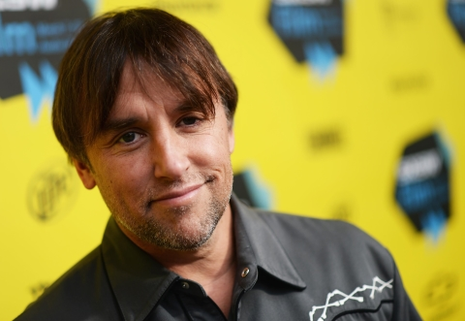
Founder and Artistic Director Richard Linklater commented on the Karlovy Vary honor with the following: "I'm so proud that AFS is receiving this incredible honor from the Karlovy Vary International Film Festival. KVIFF is fully committed to the discovery of new voices. It's deeply humbling that they've chosen to tribute AFS by shining a light on the community of independent artists that we've worked so hard to nurture. With this series of films, KVIFF celebrates creativity and uniqueness of vision, which have been the only consistent themes in the many wonderful films that have come out of Texas over the past 40 years."

Made in Texas: Tribute to Austin Film Society will present nine feature-length films and two programs of short films. Slacker, the iconic first feature of the Austin Film Society’s founder Richard Linklater, takes us to roam around Austin’s streets during an ordinary hot Texas day, meeting one-of-a-kind locals and eccentrics. Contemporary western action El Mariachi, the debut feature by Robert Rodriguez, tells the story of a kind-hearted musician who accidentally gets entangled in a web of violence.
Offbeat indie The Slow Business of Going by Greek writer-director Athina Rachel Tsangari showcases a more experimental side of film production coming from Austin. The documentary scene will be represented by Laura Dunn’s The Unforeseen, a striking, deeply poetic take on the clash between greedy developers and the local community defending the environment of the recreational area in Barton Springs.
Among the recent films from Texas, the festival will show Take Shelter, the award-winning psychological thriller of Cannes favourite Jeff Nichols, David Zellner’s minimalistic drama Kid-Thing, Bob Byington’s witty comedy Somebody Up There Likes Me and Andrew Bujalski’s retro stylised drama Computer Chess, set in a software programmers’ community, as well as a program of contemporary short films by notable up-and-coming Texas filmmakers.

The section will also include Last Night at the Alamo directed by a pioneer of Texas independent film scene, Eagle Pennell, and shot two years before the foundation of the Austin Film Society. Other early works will include a program of six shorts originally curated by Jonathan Demme as a snapshot of the punk and new wave scenes of Austin in the late 1970s and early 1980s.

Made in Texas: Tribute to Austin Film Society
Last Night at the Alamo (Eagle Pennell, 1983)
Slacker (Richard Linklater, 1991)
El Mariachi (Robert Rodriguez, 1992)
The Slow Business of Going (Athina Rachel Tsangari, 2000)
The Unforeseen (Laura Dunn, 2007)
Take Shelter (Jeff Nichols, 2011)
Kid-Thing (David Zellner, 2012)
Somebody Up There Likes Me (Bob Byington, 2012)
Computer Chess (Andrew Bujalski, 2013)
Jonathan Demme Presents: Made in Texas (program of six short films from 1980s)
Program of recent short films from Texas

